E-01 Fan Cover • Engine Shroud
2
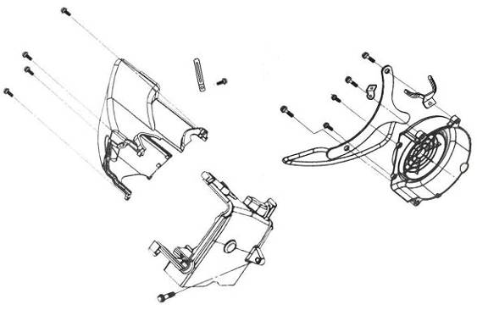
1
3
4
4
4
4
4
4
5
5
5

7
8
6
5

Ref. No | Part Number |  |  |  |  |  |  |  |  |  |  | Description |  |  |  |  |  |  |  |  |  |  |  |  |  |  |  |  |  |  |  | Reqd. No.
1 | 1961A-GYB2-A001 |  |  |  |  |  |  |  |  |  |  | Fan cover COMP. |  |  |  |  |  |  |  |  |  |  |  | 风扇盖组 |  |  |  |  |  |  |  | 1
2 | 1962A-GYB2-A000 |  |  |  |  |  |  |  |  |  |  | Shroud A ASSY. |  |  |  |  |  |  |  |  |  |  |  | 罩盖A |  |  |  |  |  |  |  | 1
3 | 1963A-GYB2-A000 |  |  |  |  |  |  |  |  |  |  | Shroud B ASSY. |  |  |  |  |  |  |  |  |  |  |  | 罩盖B |  |  |  |  |  |  |  | 1
4 | 93904-35380 |  |  |  |  |  |  |  |  |  |  | Tapping screw 5*16 |  |  |  |  |  |  |  |  |  |  |  | 平头螺钉5*16 |  |  |  |  |  |  |  | 6
5 | 96001-06025-08 |  |  |  |  |  |  |  |  |  |  | SH. flange bolt 6*25 |  |  |  |  |  |  |  |  |  |  |  | 六角缘面螺栓6*25 |  |  |  |  |  |  |  | 4
6 | 94591-28000 |  |  |  |  |  |  |  |  |  |  | Clip 2*80 |  |  |  |  |  |  |  |  |  |  |  | 扣夹2*80 |  |  |  |  |  |  |  | 1
7 | 19613-GY6-9000 |  |  |  |  |  |  |  |  |  |  | Starter motor cord clampe |  |  |  |  |  |  |  |  |  |  |  | 起动马达线夹 |  |  |  |  |  |  |  | 1
8 | 93903-34380 |  |  |  |  |  |  |  |  |  |  | Tapping screw 4*12 |  |  |  |  |  |  |  |  |  |  |  | 平头螺钉4*12 |  |  |  |  |  |  |  | 1
E-02-1 Cylinder Head Cover • Carburetor
5
5
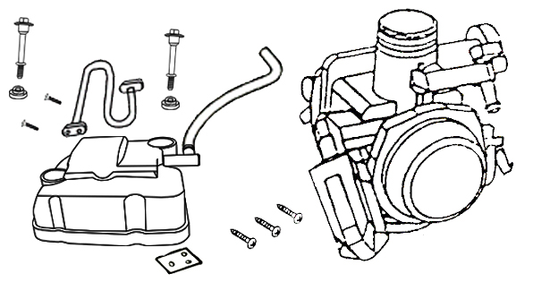
7
7
3
4
2
6
1

Ref.No | Part Number |  |  |  |  |  |  |  |  | Description |  |  |  |  |  |  |  |  |  |  |  |  |  |  |  |  |  |  |  |  |  | Reqd. No.
1 | 16100-ANA-0100 |  |  |  |  |  |  |  |  | Carburetor ASSY |  |  |  |  |  |  | 化油器总成 |  |  |  |  |  |  |  |  |  |  |  |  |  |  | 1
2 | 12302-GYB2-A000 |  |  |  |  |  |  |  |  | Breather cover |  |  |  |  |  |  | 通气管隔离板 |  |  |  |  |  |  |  |  |  |  |  |  |  |  | 1
3 | 12310-GYB2-0001 |  |  |  |  |  |  |  |  | Head cover COMP |  |  |  |  |  |  | 汽缸头盖组 |  |  |  |  |  |  |  |  |  |  |  |  |  |  | 1
4 | 1239-GYB2-A000 |  |  |  |  |  |  |  |  | Head cover gasket |  |  |  |  |  |  | 汽缸头盖垫片 |  |  |  |  |  |  |  |  |  |  |  |  |  |  | 1
5 | 90453-GYB2-A000 |  |  |  |  |  |  |  |  | Rubber washer |  |  |  |  |  |  | 橡胶密封圈 |  |  |  |  |  |  |  |  |  |  |  |  |  |  | 2
6 | 93903-34180 |  |  |  |  |  |  |  |  | Tapping screw 4x8 |  |  |  |  |  |  | 攻丝螺钉 |  |  |  |  |  |  |  |  |  |  |  |  |  |  | 3
7 | 90002-GYB2-A100 |  |  |  |  |  |  |  |  | Flange bolt |  |  |  |  |  |  | 缸头盖锁付螺栓 |  |  |  |  |  |  |  |  |  |  |  |  |  |  | 2
E-03 Cylinder Head • Hold
8
8
7
7
6
5
4
3
2
2
1
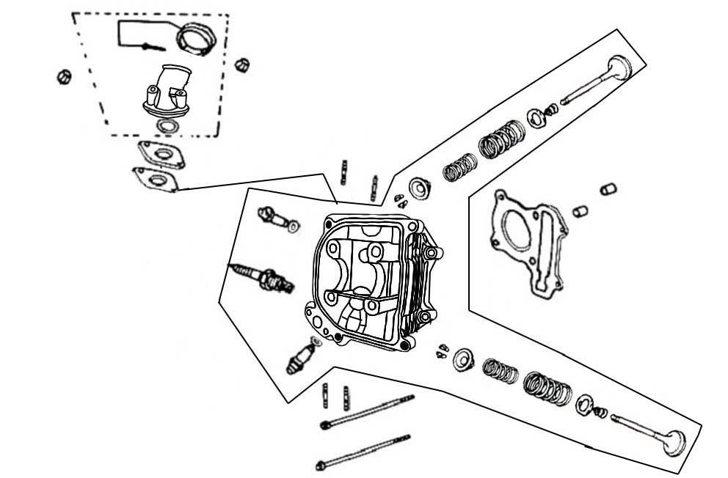
24
24
22
22
23
23
21
20
20
19
18
18
17
17
16
15
14
13
12
11
11
10
10
9
9
Ref. No | Part Number |  |  |  |  |  |  |  |  |  |  | Description |  |  |  |  |  |  |  |  |  |  |  |  |  |  |  |  |  |  |  | Reqd. No.
1 | 12200-GYB2-0002 |  |  |  |  |  |  |  |  |  |  | Cylinder head COMP |  |  |  |  |  |  |  |  | 汽缸头组 |  |  |  |  |  |  |  |  |  |  | 1
2 | 12209-H6B-9000 |  |  |  |  |  |  |  |  |  |  | Valve stem seal |  |  |  |  |  |  |  |  | 气门杆油封 |  |  |  |  |  |  |  |  |  |  | 2
3 | 1220A-A2C-0008 |  |  |  |  |  |  |  |  |  |  | Cylinder head ASSY |  |  |  |  |  |  |  |  | 汽缸头总成 |  |  |  |  |  |  |  |  |  |  | 1
4 | 12251-GYB2-0000 |  |  |  |  |  |  |  |  |  |  | Cylinder head gasket |  |  |  |  |  |  |  |  | 汽缸头垫片 |  |  |  |  |  |  |  |  |  |  | 1
5 | 14711-GYB2-A000 |  |  |  |  |  |  |  |  |  |  | IN. valve |  |  |  |  |  |  |  |  | 进气门 |  |  |  |  |  |  |  |  |  |  | 1
6 | 14721-GYB2-A000 |  |  |  |  |  |  |  |  |  |  | EX. valve |  |  |  |  |  |  |  |  | 排气门 |  |  |  |  |  |  |  |  |  |  | 1
7 | 14751-GYB2-A100 |  |  |  |  |  |  |  |  |  |  | Valve outer spring |  |  |  |  |  |  |  |  | 气门外弹簧 |  |  |  |  |  |  |  |  |  |  | 2
8 | 14761-GYB2-A100 |  |  |  |  |  |  |  |  |  |  | Valve inner spring |  |  |  |  |  |  |  |  | 气门内弹簧 |  |  |  |  |  |  |  |  |  |  | 2
9 | 14771-M8Q-0000 |  |  |  |  |  |  |  |  |  |  | Valve spring retainer |  |  |  |  |  |  |  |  | 气门弹簧承盘 |  |  |  |  |  |  |  |  |  |  | 2
10 | 14775-M9Q-0000 |  |  |  |  |  |  |  |  |  |  | Valve spring seat outer |  |  |  |  |  |  |  |  | 气门外弹簧座 |  |  |  |  |  |  |  |  |  |  | 2
11 | 14781-A01-A000 |  |  |  |  |  |  |  |  |  |  | Valve cotter |  |  |  |  |  |  |  |  | 气门锁夹 |  |  |  |  |  |  |  |  |  |  | 4
12 | 16201-ARB-0000 |  |  |  |  |  |  |  |  |  |  | Insulator gasket |  |  |  |  |  |  |  |  | 化油器绝缘垫片 |  |  |  |  |  |  |  |  |  |  | 1
13 | 16211-M92-0002 |  |  |  |  |  |  |  |  |  |  | Carburetor Insulator |  |  |  |  |  |  |  |  | 化油器隔热板 |  |  |  |  |  |  |  |  |  |  | 1
14 | 17110-ANA-0000 |  |  |  |  |  |  |  |  |  |  | IN. pipe COMP |  |  |  |  |  |  |  |  | 进气管组 |  |  |  |  |  |  |  |  |  |  | 1
15 | 1711A-ANA-0003 |  |  |  |  |  |  |  |  |  |  | IN. pipe ASSY |  |  |  |  |  |  |  |  | 进气管总成 |  |  |  |  |  |  |  |  |  |  | 1
16 | 17256-M9Q-0000 |  |  |  |  |  |  |  |  |  |  | Insulator band |  |  |  |  |  |  |  |  | 进气管固定带 |  |  |  |  |  |  |  |  |  |  | 1
17 | 90033-M9Q-0000 |  |  |  |  |  |  |  |  |  |  | Stud bolt 6x16 |  |  |  |  |  |  |  |  | 双头螺栓6X16 |  |  |  |  |  |  |  |  |  |  | 2
18 | 90033-M9Q-0000 |  |  |  |  |  |  |  |  |  |  | Stud bolt 6x16 |  |  |  |  |  |  |  |  | 双头螺栓6X16 |  |  |  |  |  |  |  |  |  |  | 2
19 | 91308-M9Q-0002 |  |  |  |  |  |  |  |  |  |  | O-Ring 27x2 |  |  |  |  |  |  |  |  | O型环27X2 |  |  |  |  |  |  |  |  |  |  | 1
20 | 91305-M9Q-0001 |  |  |  |  |  |  |  |  |  |  | O-Ring 9x1.6 |  |  |  |  |  |  |  |  | O型环9X1.6 |  |  |  |  |  |  |  |  |  |  | 2
E-03-1 Cylinder Head • Hold
18
17
17
16
15
14
13
12
11
11
10
10
9
9
8
8
7
7
6
5
4
3
2
2
1
24
24
22
22
23
23
21
20
20
19
18
Ref. No | Part Number |  |  |  |  |  |  |  |  |  |  | Description |  |  |  |  |  |  |  |  |  |  |  |  |  |  |  |  |  |  |  |  |  | Reqd. No.
21 | 98056-57718-TW |  |  |  |  |  |  |  |  |  |  | Spark plug (CR7HSA NGK) |  |  |  |  |  |  |  |  |  |  |  |  |  |  | 火星塞 |  |  |  |  |  |  | 1
22 | 94050-06080 |  |  |  |  |  |  |  |  |  |  | Flange nut 6mm |  |  |  |  |  |  |  |  |  |  |  |  |  |  | 六角缘面螺帽6MM |  |  |  |  |  |  | 2
23 | 96001-06100-08 |  |  |  |  |  |  |  |  |  |  | SH. flange bolt 6x85 |  |  |  |  |  |  |  |  |  |  |  |  |  |  | 六角缘面螺栓6X85 |  |  |  |  |  |  | 2
24 | 94301-08140 |  |  |  |  |  |  |  |  |  |  | DOWEL PIN 8X14 |  |  |  |  |  |  |  |  |  |  |  |  |  |  | 定位梢8*14 |  |  |  |  |  |  | 2
E-04 Cam Shaft • Valve
8
8
7
7
6
6
5
4
3
3
2
1
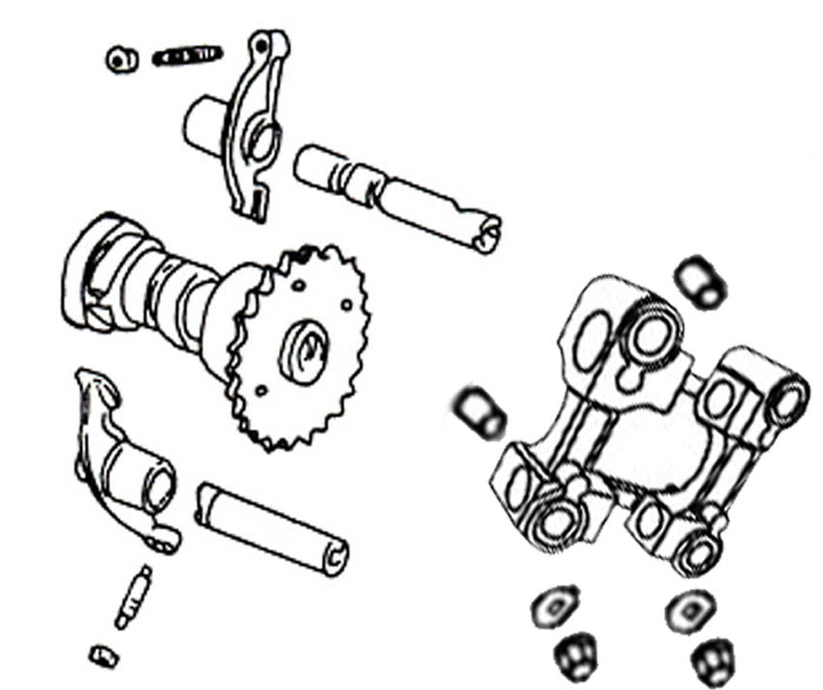
Ref. No | Part Number |  |  |  |  |  | Description |  |  |  |  |  |  |  |  |  |  |  |  |  |  |  |  |  |  |  |  |  |  |  |  | Reqd. No.
1 | 12211-GYB2-A000 |  |  |  |  |  | Cam shaft holder |  |  |  |  |  |  |  |  |  | 凸轮轴固定座 |  |  |  |  |  |  |  |  |  |  |  |  |  |  | 1
2 | 14100-GYB2-0000 |  |  |  |  |  | Cam shaft COMP |  |  |  |  |  |  |  |  |  | 凸轮轴组 |  |  |  |  |  |  |  |  |  |  |  |  |  |  | 1
3 | 1443A-GYB2-A000 |  |  |  |  |  | Valve rocker arm |  |  |  |  |  |  |  |  |  | 气门摇臂 |  |  |  |  |  |  |  |  |  |  |  |  |  |  | 2
4 | 14450-GY6-9000 |  |  |  |  |  | IN. rocker arm shaft COMP |  |  |  |  |  |  |  |  |  | 进气门摇臂轴组 |  |  |  |  |  |  |  |  |  |  |  |  |  |  | 1
5 | 14452-GY6-9000 |  |  |  |  |  | EX. rocker arm shaft COMP |  |  |  |  |  |  |  |  |  | 排气门摇臂轴组 |  |  |  |  |  |  |  |  |  |  |  |  |  |  | 1
6 | 90465-MC4-0000 |  |  |  |  |  | Washer A |  |  |  |  |  |  |  |  |  | 垫圈A |  |  |  |  |  |  |  |  |  |  |  |  |  |  | 4
7 | 94050-08080 |  |  |  |  |  | Flange nut 7mm |  |  |  |  |  |  |  |  |  | 六角缘面螺帽7MM |  |  |  |  |  |  |  |  |  |  |  |  |  |  | 4
8 | 90703-M8Q-0003 |  |  |  |  |  | Dowel pin 10x14 |  |  |  |  |  |  |  |  |  | 固定销10X14 |  |  |  |  |  |  |  |  |  |  |  |  |  |  | 2
E-05 Cam Chain • Tensioner
1
7
4
3
8
8
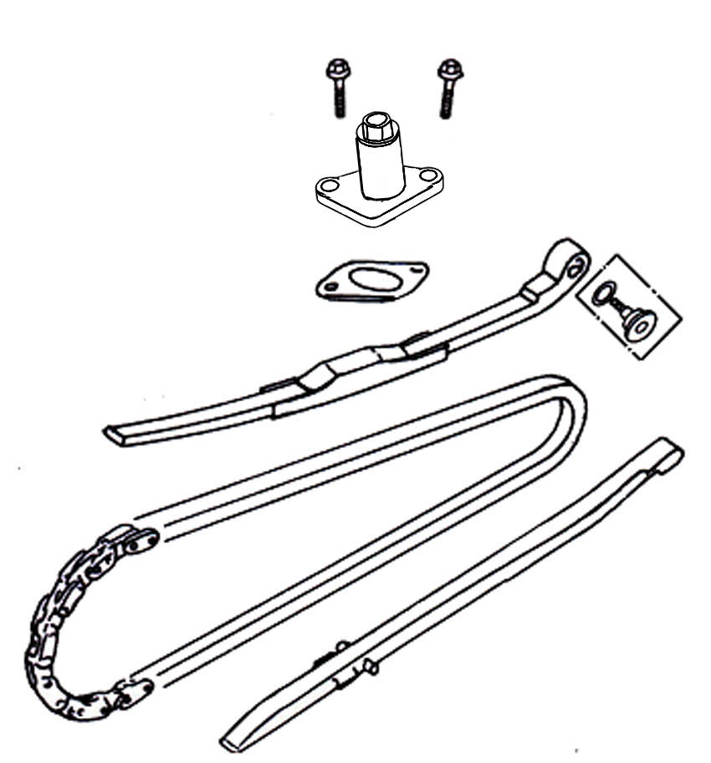
9
2
5
6
Ref. No | Part Number |  |  |  |  |  | Description |  |  |  |  |  |  |  |  |  |  |  |  |  |  |  |  |  |  |  |  |  |  |  |  |  |  |  |  | Reqd. No.
1 | 14401-M92-0031-M2 |  |  |  |  |  | Cam chain |  |  |  |  |  |  |  | 凸轮轴链条 |  |  |  |  |  |  |  |  |  |  |  |  |  |  |  |  |  |  |  |  | 1
2 | 14510-GY6-9000 |  |  |  |  |  | Cam chain tensioner |  |  |  |  |  |  |  | 凸轮链条张力器 |  |  |  |  |  |  |  |  |  |  |  |  |  |  |  |  |  |  |  |  | 1
3 | 14520-GYB2-A001 |  |  |  |  |  | Tensioner lifter ASSY |  |  |  |  |  |  |  | 链条调整器总成 |  |  |  |  |  |  |  |  |  |  |  |  |  |  |  |  |  |  |  |  | 1
4 | 14523-Z8G-0000 |  |  |  |  |  | Tensioner lifter gasket |  |  |  |  |  |  |  | 链条调整器垫片 |  |  |  |  |  |  |  |  |  |  |  |  |  |  |  |  |  |  |  |  | 1
5 | 1453A-V02-0001 |  |  |  |  |  | Tensioner pivot ASSY |  |  |  |  |  |  |  | 链条张力器枢轴螺丝总成 |  |  |  |  |  |  |  |  |  |  |  |  |  |  |  |  |  |  |  |  | 1
6 | 14531-M9Q-0000 |  |  |  |  |  | Tensioner pivot |  |  |  |  |  |  |  | 链条张力器螺栓 |  |  |  |  |  |  |  |  |  |  |  |  |  |  |  |  |  |  |  |  | 1
7 | 14610-GY6-9000 |  |  |  |  |  | Cam chain guide COMP |  |  |  |  |  |  |  | 凸轮链条导具组 |  |  |  |  |  |  |  |  |  |  |  |  |  |  |  |  |  |  |  |  | 1
8 | 96001-06022-08 |  |  |  |  |  | SH. flange bolt 6x22 |  |  |  |  |  |  |  | 六角缘面螺栓 |  |  |  |  |  |  |  |  |  |  |  |  |  |  |  |  |  |  |  |  | 2
9 | 91301-GR0-0030 |  |  |  |  |  | O-Ring 15.2x1.5 |  |  |  |  |  |  |  | O型环15.2X1.5 |  |  |  |  |  |  |  |  |  |  |  |  |  |  |  |  |  |  |  |  | 1
E-06 Cylinder
3
3
2
1
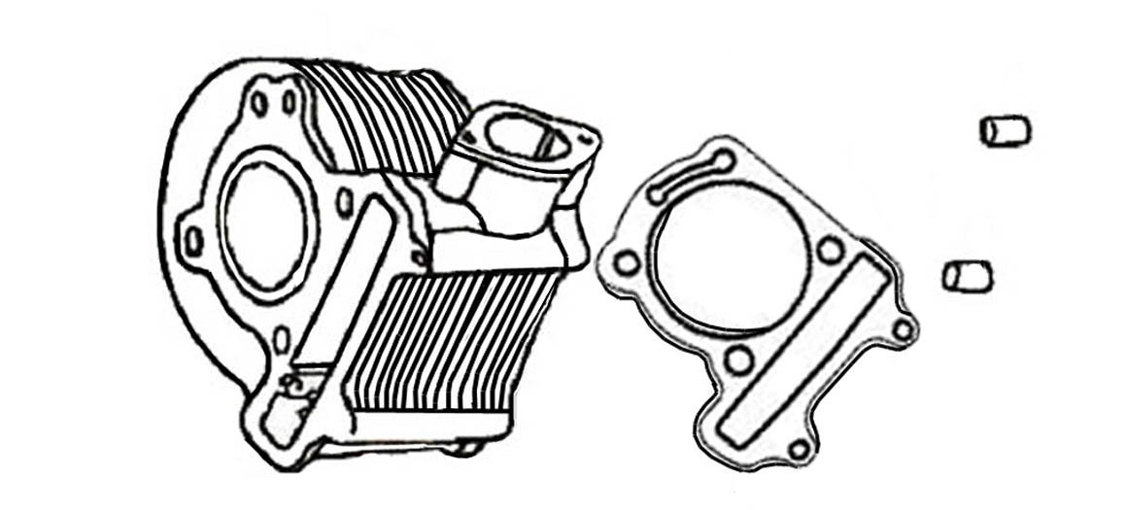
Ref. No | Part Number |  |  |  |  |  |  | Description |  |  |  |  |  |  |  |  |  |  |  |  |  |  |  |  |  |  |  |  |  |  |  |  |  | Reqd. No.
1 | 12101-GYB2-A000 |  |  |  |  |  |  | Cylinder |  |  |  |  |  | 汽缸组 |  |  |  |  |  |  |  |  |  |  |  |  |  |  |  |  |  |  |  | 1
2 | 12191-A2E-0000 |  |  |  |  |  |  | Cylinder gasket |  |  |  |  |  | 汽缸垫片 |  |  |  |  |  |  |  |  |  |  |  |  |  |  |  |  |  |  |  | 1
3 | 90703-M8Q-0003 |  |  |  |  |  |  | Dowel pin 8X14 |  |  |  |  |  | 固定销8X14 |  |  |  |  |  |  |  |  |  |  |  |  |  |  |  |  |  |  |  | 2
E-07 Right Crank Case Cover
15
16
16
15
15
15
14
13
12
12
11
10
9
8
7
6
5
4
3
2
1
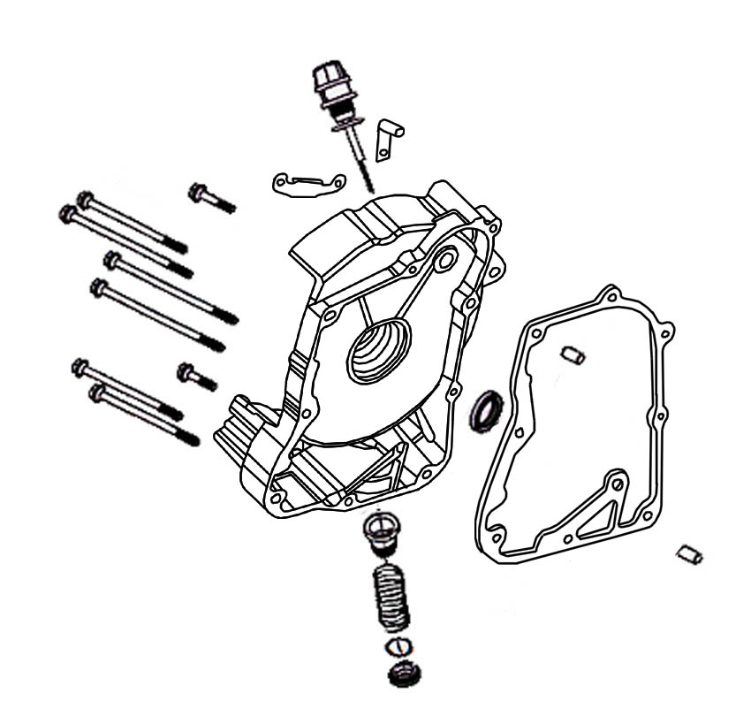
Ref. No | Part Number |  |  |  |  |  |  |  |  |  | Description |  |  |  |  |  |  |  |  |  |  |  |  |  |  |  |  |  |  |  |  |  |  | Reqd. No.
1 | 11331-GY6-0002 |  |  |  |  |  |  |  |  |  | R. crank case cover |  |  |  |  |  |  | 右曲轴箱盖 |  |  |  |  |  |  |  |  |  |  |  |  |  |  |  | 1
2 | 11394-Z8G-0000 |  |  |  |  |  |  |  |  |  | R. crank case cover gasket |  |  |  |  |  |  | 右曲轴箱盖垫片 |  |  |  |  |  |  |  |  |  |  |  |  |  |  |  | 1
3 | 12361-M9Q-0001 |  |  |  |  |  |  |  |  |  | Tappet ADJ. HOLE CAP |  |  |  |  |  |  | 滤油盖 |  |  |  |  |  |  |  |  |  |  |  |  |  |  |  | 1
4 | 15421-H66-0000 |  |  |  |  |  |  |  |  |  | Oil filter screen |  |  |  |  |  |  | 滤油网 |  |  |  |  |  |  |  |  |  |  |  |  |  |  |  | 1
5 | 15426-M9Q-0000 |  |  |  |  |  |  |  |  |  | Oil filter screen spring |  |  |  |  |  |  | 滤油网弹簧 |  |  |  |  |  |  |  |  |  |  |  |  |  |  |  | 1
6 | 1565A-AAA-0000 |  |  |  |  |  |  |  |  |  | Oil level gauge ASSY |  |  |  |  |  |  | 机油尺总成 |  |  |  |  |  |  |  |  |  |  |  |  |  |  |  | 1
7 | 19613-GY6-9000 |  |  |  |  |  |  |  |  |  | Starter motor cord clampe |  |  |  |  |  |  | 起动马达线夹 |  |  |  |  |  |  |  |  |  |  |  |  |  |  |  | 1
8 | 32961-GY6-9000 |  |  |  |  |  |  |  |  |  | Clamper ACG cord |  |  |  |  |  |  | ACG线夹 |  |  |  |  |  |  |  |  |  |  |  |  |  |  |  | 1
9 | 91201-GY6-9031 |  |  |  |  |  |  |  |  |  | Oil seal 19.8X30X5 |  |  |  |  |  |  | 油封19.8X30X5 |  |  |  |  |  |  |  |  |  |  |  |  |  |  |  | 1
10 | 91302-M9T-0002 |  |  |  |  |  |  |  |  |  | O-RING 30.8MM |  |  |  |  |  |  | O型环30.8MM |  |  |  |  |  |  |  |  |  |  |  |  |  |  |  | 1
11 | 91307-035-0000 |  |  |  |  |  |  |  |  |  | O-Ring 18x3 |  |  |  |  |  |  | O型环18X3 |  |  |  |  |  |  |  |  |  |  |  |  |  |  |  | 1
12 | 94301-08140 |  |  |  |  |  |  |  |  |  | Dowel pin 8x14 |  |  |  |  |  |  | 固定销 |  |  |  |  |  |  |  |  |  |  |  |  |  |  |  | 2
13 | 96001-06032-08 |  |  |  |  |  |  |  |  |  | SH. flange bolt 6x32 |  |  |  |  |  |  | 六角缘面螺栓6X32 |  |  |  |  |  |  |  |  |  |  |  |  |  |  |  | 1
14 | 96001-06040-08 |  |  |  |  |  |  |  |  |  | SH. flange bolt 6x40 |  |  |  |  |  |  | 六角缘面螺栓6X40 |  |  |  |  |  |  |  |  |  |  |  |  |  |  |  | 1
15 | 96001-06095-08 |  |  |  |  |  |  |  |  |  | SH. flange bolt 6x95 |  |  |  |  |  |  | 六角缘面螺栓6X95 |  |  |  |  |  |  |  |  |  |  |  |  |  |  |  | 4
16 | 96001-06110-08 |  |  |  |  |  |  |  |  |  | SH. flange bolt 6x110 |  |  |  |  |  |  | 六角缘面螺栓6X100 |  |  |  |  |  |  |  |  |  |  |  |  |  |  |  | 2
E-08 Generator • Fly Wheel
5
7

6
9
9
4
2
3
8
8
8
8
1
Ref. No | Part Number |  |  |  |  |  |  |  |  |  | Description |  |  |  |  |  |  |  |  |  |  |  |  |  |  |  |  |  |  | Reqd. No.
1 | 19510-GYB2-A000 |  |  |  |  |  |  |  |  |  | Cooling fan COMP |  |  |  |  | 冷却风扇组 |  |  |  |  |  |  |  |  |  |  |  |  |  | 1
2 | 31100-ABA-0000 |  |  |  |  |  |  |  |  |  | A. C. G. ASSY (CDI) |  |  |  |  | 交流发电机总成 |  |  |  |  |  |  |  |  |  |  |  |  |  | 1
3 | 31120-X1A-0000 |  |  |  |  |  |  |  |  |  | A. C. G. stator |  |  |  |  | 发电线圈 |  |  |  |  |  |  |  |  |  |  |  |  |  | 1
4 | 31110-ABA-0000 |  |  |  |  |  |  |  |  |  | A. C. G. flywheel |  |  |  |  | 飞轮 |  |  |  |  |  |  |  |  |  |  |  |  |  | 1
5 | 90440-166-0000 |  |  |  |  |  |  |  |  |  | Plain washer 12.2 |  |  |  |  | 平面垫圈12.2 |  |  |  |  |  |  |  |  |  |  |  |  |  | 1
6 | 92101-05012-0A |  |  |  |  |  |  |  |  |  | HEX. bolt 5 x12 |  |  |  |  | 六角缘面螺栓5X12 |  |  |  |  |  |  |  |  |  |  |  |  |  | 2
7 | 94050-12080 |  |  |  |  |  |  |  |  |  | Flange nut 12MM |  |  |  |  | 六角缘面螺帽 |  |  |  |  |  |  |  |  |  |  |  |  |  | 1
8 | 96001-06018-08 |  |  |  |  |  |  |  |  |  | SH. flange bolt 6x18 |  |  |  |  | 六角缘面螺栓 |  |  |  |  |  |  |  |  |  |  |  |  |  | 4
9 | 96001-06020-00 |  |  |  |  |  |  |  |  |  | SH. flange bolt 6x20 |  |  |  |  | 六角缘面螺栓 |  |  |  |  |  |  |  |  |  |  |  |  |  | 2
E-09 Oil Pump
1
2
3
4
7
7
6
6
5

Ref. No | Part Number |  |  |  |  |  |  | Description |  |  |  |  |  |  |  |  |  |  |  |  |  |  |  |  |  |  |  |  |  |  | Reqd. No.
1 | 15100-H12-A000 |  |  |  |  |  |  | Oil pump ASSY |  |  |  |  |  |  |  |  |  | 油泵总成 |  |  |  |  |  |  |  |  |  |  |  |  | 1
2 | 15133-GY6-9000 |  |  |  |  |  |  | Oil pump driven sprocket |  |  |  |  |  |  |  |  |  | 油泵传动链轮 |  |  |  |  |  |  |  |  |  |  |  |  | 1
3 | 15141-V02-0001-M1 |  |  |  |  |  |  | Oil pump chain |  |  |  |  |  |  |  |  |  | 油泵驱动链条 |  |  |  |  |  |  |  |  |  |  |  |  | 1
4 | 15711-GY6-9000 |  |  |  |  |  |  | Oil separator |  |  |  |  |  |  |  |  |  | 隔油板 |  |  |  |  |  |  |  |  |  |  |  |  | 1
5 | 94050-06080 |  |  |  |  |  |  | Flange nut 6MM |  |  |  |  |  |  |  |  |  | 六角缘面螺帽6MM |  |  |  |  |  |  |  |  |  |  |  |  | 1
6 | 96001-06012-08 |  |  |  |  |  |  | SH. flange bolt 6x12 |  |  |  |  |  |  |  |  |  | 六角缘面螺栓6X12 |  |  |  |  |  |  |  |  |  |  |  |  | 2
7 | 96001-06025-08 |  |  |  |  |  |  | SH. flange bolt 6x25 |  |  |  |  |  |  |  |  |  | 六角缘面螺栓6X25 |  |  |  |  |  |  |  |  |  |  |  |  | 2
 |  |  |  |  |  |  |  |  |  |  |  |  |  |  |  |  |  | 1
E-10 Starter Motor • Clutch Outer
10
10
18
17
16
15
15
15
14
13
12
11
11
11
7
9
8
8
8
6
5
4
3
2
1

Ref. No | Part Number |  |  |  |  |  |  |  |  |  | Description |  |  |  |  |  |  |  |  |  |  |  |  |  |  |  |  |  |  |  |  |  |  | Reqd. No.
1 | 28101-GY6-9000 |  |  |  |  |  |  |  |  |  | Starter reduction gear |  |  |  |  |  |  |  |  |  |  |  |  |  |  |  |  | 起动减速齿轮 |  |  |  |  |  | 1
2 | 28102-GY6-9000 |  |  |  |  |  |  |  |  |  | Starter reduction gear shaft |  |  |  |  |  |  |  |  |  |  |  |  |  |  |  |  | 起动减速齿轮轴 |  |  |  |  |  | 1
3 | 28110-GY6-9000 |  |  |  |  |  |  |  |  |  | Starter clutch gear COMP |  |  |  |  |  |  |  |  |  |  |  |  |  |  |  |  | 起动离合器齿轮组 |  |  |  |  |  | 1
4 | 2812A-V02-0005-TW |  |  |  |  |  |  |  |  |  | Starter clutch outer ASSY |  |  |  |  |  |  |  |  |  |  |  |  |  |  |  |  | 起动离合器外套总成 |  |  |  |  |  | 1
5 | 28120-GY6-900E |  |  |  |  |  |  |  |  |  | Starter clutch outer COMP |  |  |  |  |  |  |  |  |  |  |  |  |  |  |  |  | 起动离合器外套组 |  |  |  |  |  | 1
6 | 28125-GY6-9000 |  |  |  |  |  |  |  |  |  | Starter clutch flange |  |  |  |  |  |  |  |  |  |  |  |  |  |  |  |  | 起动离合器凸缘 |  |  |  |  |  | 1
7 | 32410-H2G-0000 |  |  |  |  |  |  |  |  |  | Starter motor cable |  |  |  |  |  |  |  |  |  |  |  |  |  |  |  |  | 起动马达导线 |  |  |  |  |  | 1
8 | 28126-323-0001 |  |  |  |  |  |  |  |  |  | Starter clutch roller spring cap |  |  |  |  |  |  |  |  |  |  |  |  |  |  |  |  | 滚子弹簧盒 |  |  |  |  |  | 3
9 | 31200-GY6-0000 |  |  |  |  |  |  |  |  |  | Starter motor ASSY |  |  |  |  |  |  |  |  |  |  |  |  |  |  |  |  | 起动马达总成 |  |  |  |  |  | 1
10 | 96001-06016-08 |  |  |  |  |  |  |  |  |  | SH. flange bolt 6x16 |  |  |  |  |  |  |  |  |  |  |  |  |  |  |  |  | 六角缘面螺栓6X16 |  |  |  |  |  | 2
11 | 90001-GY6-9000 |  |  |  |  |  |  |  |  |  | Socket bolt 6x10 |  |  |  |  |  |  |  |  |  |  |  |  |  |  |  |  | 内六角螺栓6X10 |  |  |  |  |  | 3
12 | 90201-GY6-9000 |  |  |  |  |  |  |  |  |  | Lock nut 22MM |  |  |  |  |  |  |  |  |  |  |  |  |  |  |  |  | 锁定螺帽22MM |  |  |  |  |  | 1
13 | 90403-GY6-9000 |  |  |  |  |  |  |  |  |  | Thrust washer 22.2x31x2.5 |  |  |  |  |  |  |  |  |  |  |  |  |  |  |  |  | 垫圈22.3X31X2.5 |  |  |  |  |  | 1
14 | 90701-GY6-9000 |  |  |  |  |  |  |  |  |  | Dowel pin 5x6 |  |  |  |  |  |  |  |  |  |  |  |  |  |  |  |  | 固定销5X6 |  |  |  |  |  | 1
15 | 91101-179-7100 |  |  |  |  |  |  |  |  |  | Roller 10x10 |  |  |  |  |  |  |  |  |  |  |  |  |  |  |  |  | 滚子10X10 |  |  |  |  |  | 3
16 | 91104-GY6-9010-M1 |  |  |  |  |  |  |  |  |  | Needle bearing 28x32x17 |  |  |  |  |  |  |  |  |  |  |  |  |  |  |  |  | 滚针轴承28X32X17 |  |  |  |  |  | 1
17 | 91309-425-0030 |  |  |  |  |  |  |  |  |  | O-Ring 24.4x3.1 |  |  |  |  |  |  |  |  |  |  |  |  |  |  |  |  | O型环24.4X3.1 |  |  |  |  |  | 1
18 | 91981-KN7-6700 |  |  |  |  |  |  |  |  |  | Washer screw 5x8 |  |  |  |  |  |  |  |  |  |  |  |  |  |  |  |  | 垫圈螺丝5X8 |  |  |  |  |  | 1
E-11 Left Crank Case Cover
6
6
6
6
6
6
6
6
6
5
5
4

2
1
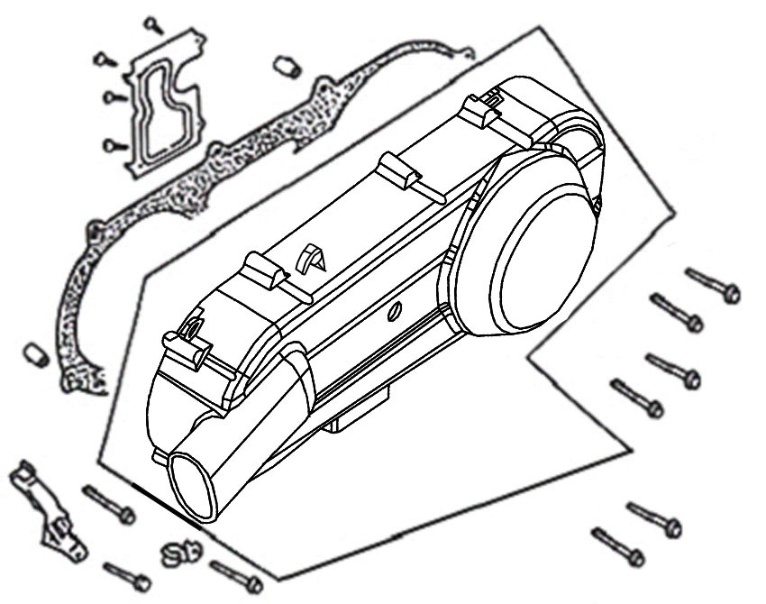

Ref. No | Part Number |  |  |  |  |  |  |  |  |  | Description |  |  |  |  |  |  |  |  |  |  |  |  |  |  |  |  |  |  |  | Reqd. No.
1 | 11341-ABA-0200-S1 |  |  |  |  |  |  |  |  |  | L. crank case cover |  |  |  |  |  |  |  |  |  |  |  | 左曲轴箱盖 |  |  |  |  |  |  |  | 1
2 | 11381-ABA-0000 |  |  |  |  |  |  |  |  |  | Throttle cable clamper |  |  |  |  |  |  |  |  |  |  |  | 节流导线夹 |  |  |  |  |  |  |  | 1
3 | 11383-GY6-A000 |  |  |  |  |  |  |  |  |  | Breather drain tube clamper |  |  |  |  |  |  |  |  |  |  |  | 刹车导线夹 |  |  |  |  |  |  |  | 1
4 | 11395-KC1-0000 |  |  |  |  |  |  |  |  |  | L cover gasket |  |  |  |  |  |  |  |  |  |  |  | 左曲轴箱盖垫片 |  |  |  |  |  |  |  | 1
5 | 94301-08140 |  |  |  |  |  |  |  |  |  | Dowel pin 8x14 |  |  |  |  |  |  |  |  |  |  |  | 固定销8X14 |  |  |  |  |  |  |  | 2
6 | 96001-06040-08 |  |  |  |  |  |  |  |  |  | SH. flange bolt6X40 |  |  |  |  |  |  |  |  |  |  |  | 六角缘面螺栓6*40 |  |  |  |  |  |  |  | 9
E-12 Drive Face • Kick Starter Spindle
1
16
17
12
23
11
14
26
15
13
22
10
9
8
7
7
7
7
9
7
7
9
2
20
24
3
6
4
5
23
19
21
18
25
Ref. No | Part Number |  |  | Description |  |  |  |  |  |  |  |  |  |  |  |  |  |  |  |  |  |  |  |  |  |  |  |  |  |  |  |  |  | Reqd. No.
1 | 11206-GY6-9000 |  |  | Kick return stopper plate |  |  |  |  |  |  |  |  |  |  |  |  |  |  |  |  |  |  |  |  | 起动回位制止器 |  |  |  |  |  |  |  |  | 1
2 | 22102-GY6-9000 |  |  | Drive face |  |  |  |  |  |  |  |  |  |  |  |  |  |  |  |  |  |  |  |  | 驱动盘 |  |  |  |  |  |  |  |  | 1
3 | 22105-GY6-9001 |  |  | Drive face boss |  |  |  |  |  |  |  |  |  |  |  |  |  |  |  |  |  |  |  |  | 驱动盘衬套 |  |  |  |  |  |  |  |  | 1
4 | 2211A-ABA-0000 |  |  | Movable drive face ASSY |  |  |  |  |  |  |  |  |  |  |  |  |  |  |  |  |  |  |  |  | 滑动驱动盘总成 |  |  |  |  |  |  |  |  | 1
5 | 22110-H69-0000 |  |  | Movable drive face COMP |  |  |  |  |  |  |  |  |  |  |  |  |  |  |  |  |  |  |  |  | 滑动驱动盘组 |  |  |  |  |  |  |  |  | 1
6 | 22112-H69-3000 |  |  | Bush 24x28x30 |  |  |  |  |  |  |  |  |  |  |  |  |  |  |  |  |  |  |  |  | 衬套24X28X30 |  |  |  |  |  |  |  |  | 1
7 | 22121-M9B-0000 |  |  | Weight roller COMP |  |  |  |  |  |  |  |  |  |  |  |  |  |  |  |  |  |  |  |  | 配重滚子组 |  |  |  |  |  |  |  |  | 6
8 | 22131-H69-0000 |  |  | Ramp plate |  |  |  |  |  |  |  |  |  |  |  |  |  |  |  |  |  |  |  |  | 斜板 |  |  |  |  |  |  |  |  | 1
9 | 22132-H69-0000 |  |  | Slide piece |  |  |  |  |  |  |  |  |  |  |  |  |  |  |  |  |  |  |  |  | 滑动片 |  |  |  |  |  |  |  |  | 3
10 | 28221-GY6-9000 |  |  | Kick starter driven gear |  |  |  |  |  |  |  |  |  |  |  |  |  |  |  |  |  |  |  |  | 起动齿轮 |  |  |  |  |  |  |  |  | 1
11 | 28223-KG8-0000 |  |  | Starter gear friction spring |  |  |  |  |  |  |  |  |  |  |  |  |  |  |  |  |  |  |  |  | 起动齿轮摩擦弹簧 |  |  |  |  |  |  |  |  | 1
12 | 2823A-V02-9200 |  |  | Starter idle gear ASSY |  |  |  |  |  |  |  |  |  |  |  |  |  |  |  |  |  |  |  |  | 起动减速齿轮总成 |  |  |  |  |  |  |  |  | 1
13 | 28230-GY6-9400 |  |  | Starter idle gear COMP |  |  |  |  |  |  |  |  |  |  |  |  |  |  |  |  |  |  |  |  | 起动减速齿轮组 |  |  |  |  |  |  |  |  | 1
14 | 28241-GY6-9400 |  |  | Starter idle shaft |  |  |  |  |  |  |  |  |  |  |  |  |  |  |  |  |  |  |  |  | 起动减速轴 |  |  |  |  |  |  |  |  | 1
15 | 28242-GA7-0000 |  |  | Starter idle spring |  |  |  |  |  |  |  |  |  |  |  |  |  |  |  |  |  |  |  |  | 起动减速轴弹簧 |  |  |  |  |  |  |  |  | 1
16 | 28250-GY6-900B |  |  | Kick starter spindle COMP |  |  |  |  |  |  |  |  |  |  |  |  |  |  |  |  |  |  |  |  | 起动轴组 |  |  |  |  |  |  |  |  | 1
17 | 28254-GA7-003A |  |  | Bush 12x16x12 |  |  |  |  |  |  |  |  |  |  |  |  |  |  |  |  |  |  |  |  | 衬套12X16X12 |  |  |  |  |  |  |  |  | 1
18 | 28254-KG8-910A |  |  | Kick spindle bush 14*18*16 |  |  |  |  |  |  |  |  |  |  |  |  |  |  |  |  |  |  |  |  | 起动杆衬套 |  |  |  |  |  |  |  |  | 1
19 | 28281-KG8-9011 |  |  | Kick starter spring |  |  |  |  |  |  |  |  |  |  |  |  |  |  |  |  |  |  |  |  | 起动杆弹簧 |  |  |  |  |  |  |  |  | 1
20 | 90440-166-0000 |  |  | Plain washer 12.2 |  |  |  |  |  |  |  |  |  |  |  |  |  |  |  |  |  |  |  |  | 平头垫圈12.2 |  |  |  |  |  |  |  |  | 1
E-12-1 Drive Face • Kick Starter Spindle
19
21
18
25
1
16
17
12
23
11
14
26
15
13
22
10
9
8
7
7
7
7
9
7
7
9
2
20
24
3
6
4
5
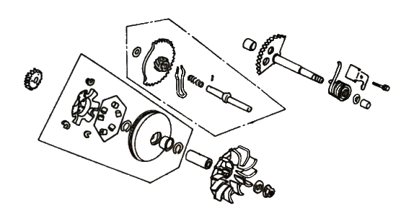
23
Ref. No | Part Number |  |  |  |  |  |  |  |  |  | Description |  |  |  |  |  |  |  |  |  |  |  |  |  |  |  |  |  |  |  | Reqd. No.
21 | 90451-155-0000 |  |  |  |  |  |  |  |  |  | Washer 14MM |  |  |  |  |  |  | 垫圈14MM |  |  |  |  |  |  |  |  |  |  |  |  | 1
22 | 90452-KG8-0000 |  |  |  |  |  |  |  |  |  | Washer 12.5MM |  |  |  |  |  |  | 垫圈12.5MM |  |  |  |  |  |  |  |  |  |  |  |  | 1
23 | 90601-M9Q-9000 |  |  |  |  |  |  |  |  |  | Clip 28MM |  |  |  |  |  |  | 环夹28MM |  |  |  |  |  |  |  |  |  |  |  |  | 2
24 | 94050-12080 |  |  |  |  |  |  |  |  |  | Flange nut 12MM |  |  |  |  |  |  | 六角螺帽12MM |  |  |  |  |  |  |  |  |  |  |  |  | 1
25 | 96001-06014-08 |  |  |  |  |  |  |  |  |  | SH. flange bolt 6x14 |  |  |  |  |  |  | 六角缘面螺栓6X14 |  |  |  |  |  |  |  |  |  |  |  |  | 1
26 | 96220-30085 |  |  |  |  |  |  |  |  |  | Roller 3x8.5 |  |  |  |  |  |  | 滚针3X8.5 |  |  |  |  |  |  |  |  |  |  |  |  | 1
E-13 Driven Pulley
6
6
6
26
25
24
24
23
22
21
20
20
20
19
18
17
16
15
14
14
14
13
13
13
12
11
10
9
8
7
7
7
5
5
5
4
3
2
1
Ref. No | Part Number |  |  |  |  |  |  |  | Description |  |  |  |  |  |  |  |  |  |  |  |  |  |  |  |  |  |  |  |  |  |  |  | Reqd. No.
1 | 22101-ABA-0000 |  |  |  |  |  |  |  | Clutch outer |  |  |  |  |  |  |  |  |  |  |  |  | 离合器外套 |  |  |  |  |  |  |  |  |  |  | 1
2 | 22300-ABA-0000 |  |  |  |  |  |  |  | Drive plate ASSY |  |  |  |  |  |  |  |  |  |  |  |  | 驱动盘总成 |  |  |  |  |  |  |  |  |  |  | 1
3 | 22350-H69-0000 |  |  |  |  |  |  |  | Drive plate COMP |  |  |  |  |  |  |  |  |  |  |  |  | 驱动板组 |  |  |  |  |  |  |  |  |  |  | 1
4 | 22361-H69-0000 |  |  |  |  |  |  |  | Clutch side plate |  |  |  |  |  |  |  |  |  |  |  |  | 离合器侧板 |  |  |  |  |  |  |  |  |  |  | 1
5 | 22401-H69-0000 |  |  |  |  |  |  |  | Clutch spring |  |  |  |  |  |  |  |  |  |  |  |  | 离合器弹簧 |  |  |  |  |  |  |  |  |  |  | 3
6 | 22530-ABA-0000 |  |  |  |  |  |  |  | Clutch weight COMP |  |  |  |  |  |  |  |  |  |  |  |  | 离合器片组 |  |  |  |  |  |  |  |  |  |  | 3
7 | 22804-H69-0000 |  |  |  |  |  |  |  | Clutch damper rubber |  |  |  |  |  |  |  |  |  |  |  |  | 离合器防震橡胶 |  |  |  |  |  |  |  |  |  |  | 3
8 | 23010-ABA-0000 |  |  |  |  |  |  |  | Driven pulley ASSY |  |  |  |  |  |  |  |  |  |  |  |  | 传动皮带盘总成 |  |  |  |  |  |  |  |  |  |  | 1
9 | 23100-A2E-0001 |  |  |  |  |  |  |  | Drive belt |  |  |  |  |  |  |  |  |  |  |  |  | 传动皮带 |  |  |  |  |  |  |  |  |  |  | 1
10 | 23200-H69-0000 |  |  |  |  |  |  |  | Driven face ASSY |  |  |  |  |  |  |  |  |  |  |  |  | 传动盘总成 |  |  |  |  |  |  |  |  |  |  | 1
11 | 23210-H69-0000 |  |  |  |  |  |  |  | Driven face COMP |  |  |  |  |  |  |  |  |  |  |  |  | 传动盘组 |  |  |  |  |  |  |  |  |  |  | 1
12 | 23220-H69-0000 |  |  |  |  |  |  |  | Movable driven face COMP |  |  |  |  |  |  |  |  |  |  |  |  | 滑动传动盘组 |  |  |  |  |  |  |  |  |  |  | 1
13 | 23225-H69-0000 |  |  |  |  |  |  |  | Roller guide pin |  |  |  |  |  |  |  |  |  |  |  |  | 滚子导销 |  |  |  |  |  |  |  |  |  |  | 3
14 | 23226-H69-0000 |  |  |  |  |  |  |  | Guide roller |  |  |  |  |  |  |  |  |  |  |  |  | 滚子 |  |  |  |  |  |  |  |  |  |  | 3
15 | 23233-M92-0000 |  |  |  |  |  |  |  | Driven face spring |  |  |  |  |  |  |  |  |  |  |  |  | 驱动弹簧 |  |  |  |  |  |  |  |  |  |  | 1
16 | 23237-H69-0000 |  |  |  |  |  |  |  | Seal collar |  |  |  |  |  |  |  |  |  |  |  |  | 油封存轴环 |  |  |  |  |  |  |  |  |  |  | 1
17 | 23238-H69-0000 |  |  |  |  |  |  |  | Spring collar |  |  |  |  |  |  |  |  |  |  |  |  | 弹簧轴环 |  |  |  |  |  |  |  |  |  |  | 1
18 | 90202-M9Q-0000 |  |  |  |  |  |  |  | Special nut 28MM |  |  |  |  |  |  |  |  |  |  |  |  | 特殊螺帽28MM |  |  |  |  |  |  |  |  |  |  | 1
19 | 90440-166-0000 |  |  |  |  |  |  |  | Plain washer 10.2X20X2.0 |  |  |  |  |  |  |  |  |  |  |  |  | 平垫圈10.2X29X2.0 |  |  |  |  |  |  |  |  |  |  | 1
20 | 94540-07010 |  |  |  |  |  |  |  | Cir clip 7MM |  |  |  |  |  |  |  |  |  |  |  |  | 环夹7MM |  |  |  |  |  |  |  |  |  |  | 3
E-13-1 Driven Pulley
6
6
6
26
25
24
24
23
22
21
20
20
20
19
18
17
16
15
14
14
14
13
13
13
12
11
10
9
8
7
7
7
5
5
5
4
3
2
1
Ref. No | Part Number |  |  |  |  |  |  |  | Description |  |  |  |  |  |  |  |  |  |  |  |  |  |  |  |  |  |  |  |  |  | Reqd. No.
21 | 91001-GY6-901A-M1 |  |  |  |  |  |  |  | Needle bearing 17X25X18 |  |  |  |  |  |  |  |  |  |  |  |  | 滚针轴承17X25X18 |  |  |  |  |  |  |  |  | 1
22 | 91002-H6B-3001 |  |  |  |  |  |  |  | Radial ball bearing 6902U |  |  |  |  |  |  |  |  |  |  |  |  | 轴承 |  |  |  |  |  |  |  |  | 1
23 | 91211-V02-0000 |  |  |  |  |  |  |  | Driven face seal 34x41x4 |  |  |  |  |  |  |  |  |  |  |  |  | 传动盘油封34X41X4 |  |  |  |  |  |  |  |  | 2
24 | 91384-M9Q-0002 |  |  |  |  |  |  |  | O-Ring 38.8x1.9 |  |  |  |  |  |  |  |  |  |  |  |  | O环38.8X1.9 |  |  |  |  |  |  |  |  | 2
25 | 94050-12080 |  |  |  |  |  |  |  | Flange nut 10MM |  |  |  |  |  |  |  |  |  |  |  |  | 六角螺帽10MM |  |  |  |  |  |  |  |  | 1
26 | 94520-28000 |  |  |  |  |  |  |  | Cir clip 28MM |  |  |  |  |  |  |  |  |  |  |  |  | 环夹28MM |  |  |  |  |  |  |  |  | 1
E-14 Transmission
7
7
2
10
15
14
4
9
11
8
3
14
13
12
6
5
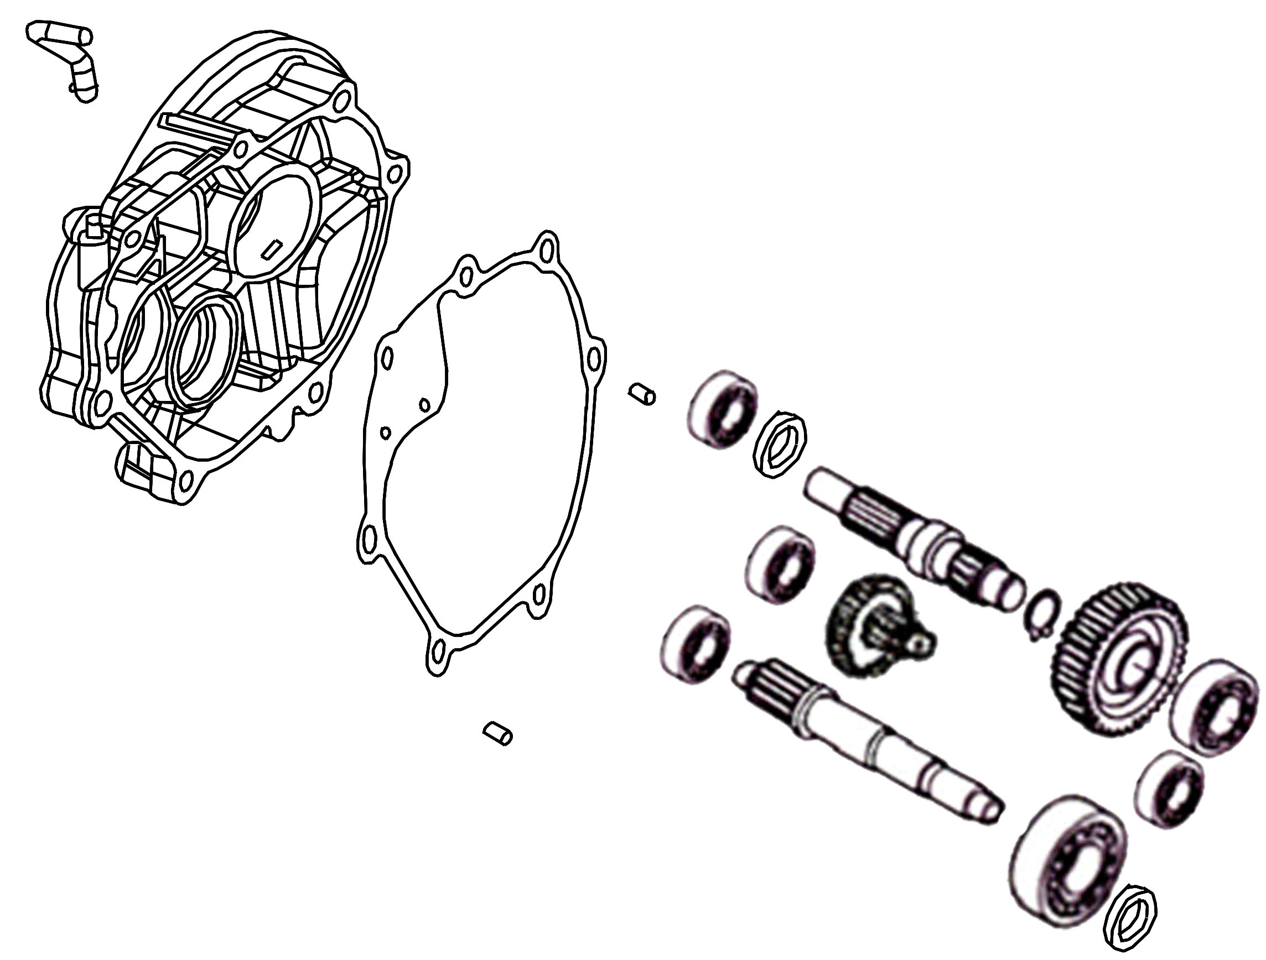
1
16
Ref. No | Part Number |  |  |  | Description |  |  |  |  |  |  |  |  |  |  |  |  |  |  |  |  |  |  |  |  |  |  |  |  |  |  |  | Reqd. No.
1 | 21200-AFA-0001 |  |  |  | Mission case COMP |  |  |  |  |  |  |  |  |  |  |  |  |  |  |  |  |  |  |  |  | 变速箱组 |  |  |  |  |  |  | 1
2 | 21395-Z2D-0000 |  |  |  | Mission cover gasket |  |  |  |  |  |  |  |  |  |  |  |  |  |  |  |  |  |  |  |  | 变速箱垫片 |  |  |  |  |  |  | 1
3 | 23411-ABA-0001 |  |  |  | Drive shaft |  |  |  |  |  |  |  |  |  |  |  |  |  |  |  |  |  |  |  |  | 驱动轴 |  |  |  |  |  |  | 1
4 | 23420-Z7P-0100-M2 |  |  |  | Counter shaft COMP. |  |  |  |  |  |  |  |  |  |  |  |  |  |  |  |  |  |  |  |  | 副轴组 |  |  |  |  |  |  | 1
5 | 23431-ABA-0000 |  |  |  | Final shaft |  |  |  |  |  |  |  |  |  |  |  |  |  |  |  |  |  |  |  |  | 最终轴 |  |  |  |  |  |  | 1
6 | 23432-HHA-0100-M2 |  |  |  | Final gear 42T |  |  |  |  |  |  |  |  |  |  |  |  |  |  |  |  |  |  |  |  | 最终齿轮 |  |  |  |  |  |  | 1
7 | 90703-M8Q-0003 |  |  |  | Dowel pin 10*14 |  |  |  |  |  |  |  |  |  |  |  |  |  |  |  |  |  |  |  |  | 定位销10*14 |  |  |  |  |  |  | 2
8 | 91003-M8Q-0000 |  |  |  | Radial ball BRG. CSB301 |  |  |  |  |  |  |  |  |  |  |  |  |  |  |  |  |  |  |  |  | 轴承CSB301 |  |  |  |  |  |  | 1
9 | 91104-KN7-6700-M1 |  |  |  | Radial ball BRG. CSB204 |  |  |  |  |  |  |  |  |  |  |  |  |  |  |  |  |  |  |  |  | 轴承CSB204 |  |  |  |  |  |  | 1
10 | 91201-HHA-3001 |  |  |  | Oil seal 32*47*7 |  |  |  |  |  |  |  |  |  |  |  |  |  |  |  |  |  |  |  |  | 油封32*47*7 |  |  |  |  |  |  | 1
11 | 91202-KJ9-0030-M1 |  |  |  | Oil seal 20*32*6 |  |  |  |  |  |  |  |  |  |  |  |  |  |  |  |  |  |  |  |  | 油封20*32*6 |  |  |  |  |  |  | 1
12 | 94510-22000 |  |  |  | EX. cir-clip 22MM |  |  |  |  |  |  |  |  |  |  |  |  |  |  |  |  |  |  |  |  | 外环夹22MM |  |  |  |  |  |  | 1
13 | 96100-62030-00 |  |  |  | Radial ball BRG. 6203 |  |  |  |  |  |  |  |  |  |  |  |  |  |  |  |  |  |  |  |  | 轴承6203 |  |  |  |  |  |  | 1
14 | 96100-63013-00 |  |  |  | Radial ball BRG 6301 |  |  |  |  |  |  |  |  |  |  |  |  |  |  |  |  |  |  |  |  | 轴承6301 |  |  |  |  |  |  | 2
15 | 96100-62043-00 |  |  |  | Ball radial bearing 6204 |  |  |  |  |  |  |  |  |  |  |  |  |  |  |  |  |  |  |  |  | 轴承6204 |  |  |  |  |  |  | 1
16 | 11221-ABA-0000 |  |  |  | Mission breather tube |  |  |  |  |  |  |  |  |  |  |  |  |  |  |  |  |  |  |  |  | 变速箱通气管 |  |  |  |  |  |  | 1
E-15 Crank Case
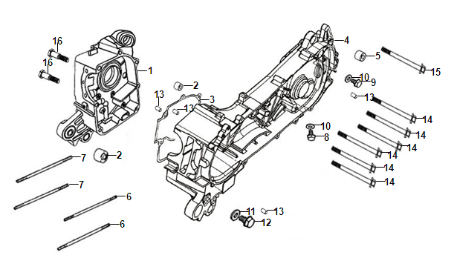
Ref. No | Part Number |  |  |  | Description |  |  |  |  |  |  |  |  |  |  |  |  |  |  |  |  |  |  |  |  |  |  |  |  |  |  |  |  | Reqd. No.
1 | 11100-A2C-0000 |  |  |  | R. crank case COMP |  |  |  |  |  |  |  |  |  |  |  |  |  | 右曲轴箱 |  |  |  |  |  |  |  |  |  |  |  |  |  |  | 1
2 | 11102-M8Q-3000 |  |  |  | ENG. hanger rubber bush |  |  |  |  |  |  |  |  |  |  |  |  |  | 引擎悬吊橡皮 |  |  |  |  |  |  |  |  |  |  |  |  |  |  | 2
3 | 11192-Z8G-0000 |  |  |  | Crank case gasket |  |  |  |  |  |  |  |  |  |  |  |  |  | 曲轴箱垫片 |  |  |  |  |  |  |  |  |  |  |  |  |  |  | 1
4 | 11200-A2C-0100 |  |  |  | L. crank case COMP |  |  |  |  |  |  |  |  |  |  |  |  |  | 左曲轴箱 |  |  |  |  |  |  |  |  |  |  |  |  |  |  | 1
5 | 11203-M9Q-3000 |  |  |  | RR. cushion under rubber bush |  |  |  |  |  |  |  |  |  |  |  |  |  | 后避震橡皮衬套 |  |  |  |  |  |  |  |  |  |  |  |  |  |  | 1
6 | 90031-GYB2-A000 |  |  |  | Stud bolt 8X187.5 |  |  |  |  |  |  |  |  |  |  |  |  |  | 双头螺栓8*187.5 |  |  |  |  |  |  |  |  |  |  |  |  |  |  | 2
7 | 90032-GYB2-A000 |  |  |  | Stud bolt 8X195.5 |  |  |  |  |  |  |  |  |  |  |  |  |  | 双头螺栓8*195.5 |  |  |  |  |  |  |  |  |  |  |  |  |  |  | 2
8 | 90103-H68-0002 |  |  |  | Special bolt 8MM |  |  |  |  |  |  |  |  |  |  |  |  |  | 特殊螺栓8MM |  |  |  |  |  |  |  |  |  |  |  |  |  |  | 1
9 | 90103-H68-0000 |  |  |  | Special bolt 8MM |  |  |  |  |  |  |  |  |  |  |  |  |  | 特殊螺栓8MM |  |  |  |  |  |  |  |  |  |  |  |  |  |  | 1
10 | 94109-12000 |  |  |  | Washer 8MM |  |  |  |  |  |  |  |  |  |  |  |  |  | 垫片8MM |  |  |  |  |  |  |  |  |  |  |  |  |  |  | 2
11 | 92800-12000 |  |  |  | Drain plug bolt 12MM |  |  |  |  |  |  |  |  |  |  |  |  |  | 泄油孔螺栓12MM |  |  |  |  |  |  |  |  |  |  |  |  |  |  | 1
12 | 94109-12000 |  |  |  | Drain plug washer 12MM |  |  |  |  |  |  |  |  |  |  |  |  |  | 泄油孔垫片12MM |  |  |  |  |  |  |  |  |  |  |  |  |  |  | 1
13 | 94301-08140 |  |  |  | Dowel pin 8X14 |  |  |  |  |  |  |  |  |  |  |  |  |  | 定位销8*14 |  |  |  |  |  |  |  |  |  |  |  |  |  |  | 4
14 | 95701-08055-00 |  |  |  | SH. flange bolt 8X55 |  |  |  |  |  |  |  |  |  |  |  |  |  | 六角缘面螺栓8*55 |  |  |  |  |  |  |  |  |  |  |  |  |  |  | 6
15 | 95701-08060-00 |  |  |  | SH. flange bolt 8X60 |  |  |  |  |  |  |  |  |  |  |  |  |  | 六角缘面螺栓8*60 |  |  |  |  |  |  |  |  |  |  |  |  |  |  | 1
16 | 96001-06050-00 |  |  |  | Flange sh. bolt 6X50 |  |  |  |  |  |  |  |  |  |  |  |  |  | 六角缘面螺栓6*50 |  |  |  |  |  |  |  |  |  |  |  |  |  |  | 2
E-16 Crank Shaft • Piston
5
5
4
3
2
1
Ref. No |  | Part Number |  |  |  | Description |  |  |  |  |  |  |  |  |  |  |  |  |  |  |  |  |  |  |  |  |  |  |  |  |  |  |  |  | Reqd. No.
1 |  | 13000-ABA-0002 |  |  |  | Crank shaft COMP |  |  |  |  |  |  |  |  |  |  |  |  |  | 曲轴组 |  |  |  |  |  |  |  |  |  |  |  |  |  |  | 1
2 |  | 13010-GYB2-A000 |  |  |  | Piston ring set |  |  |  |  |  |  |  |  |  |  |  |  |  | 活塞环 |  |  |  |  |  |  |  |  |  |  |  |  |  |  | 1
3 |  | 13101-GYB2-A000 |  |  |  | Piston |  |  |  |  |  |  |  |  |  |  |  |  |  | 活塞 |  |  |  |  |  |  |  |  |  |  |  |  |  |  | 1
4 |  | 13111-GYB2-A000 |  |  |  | Piston pin |  |  |  |  |  |  |  |  |  |  |  |  |  | 活塞销 |  |  |  |  |  |  |  |  |  |  |  |  |  |  | 1
5 |  | 94601-15000 |  |  |  | Piston pin clip 15 |  |  |  |  |  |  |  |  |  |  |  |  |  | 活塞销夹 |  |  |  |  |  |  |  |  |  |  |  |  |  |  | 2
E-17 AICV TUBE
4
1
2
3
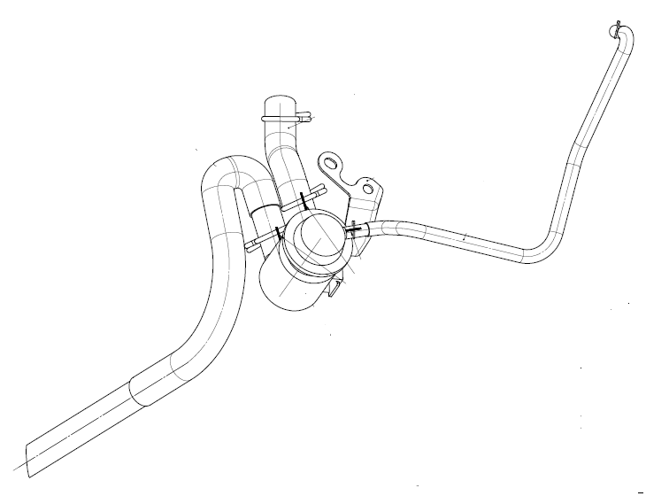
Ref. No |  | Part Number |  |  |  | Description |  |  |  |  |  |  |  |  |  |  |  |  |  |  |  |  |  |  |  |  |  |  |  |  |  |  |  |  | Reqd. No.
1 |  | 18650-35A-6000 |  |  |  | AICV |  |  |  |  |  |  |  |  |  |  |  |  |  | 组合阀总成 |  |  |  |  |  |  |  |  |  |  |  |  |  |  | 1
2 |  | 18860-H6H-9103 |  |  |  | A I C V tube |  |  |  |  |  |  |  |  |  |  |  |  |  | 空气切断阀管 |  |  |  |  |  |  |  |  |  |  |  |  |  |  | 1
3 |  | 18657-ARA-0101 |  |  |  | AICV P.B. joint tube |  |  |  |  |  |  |  |  |  |  |  |  |  | AICV管 |  |  |  |  |  |  |  |  |  |  |  |  |  |  | 1
4 |  | 18670-A2E-0001 |  |  |  | AICV tube |  |  |  |  |  |  |  |  |  |  |  |  |  | AICV管 |  |  |  |  |  |  |  |  |  |  |  |  |  |  | 1
F-01Head Light
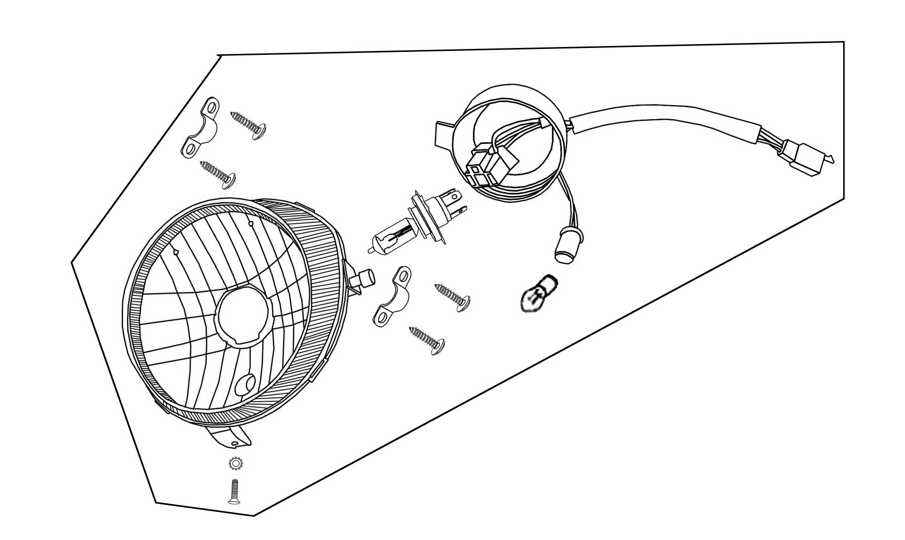
9
8
8
8
8
7
6
5
4
4
3
2
1
Ref. No |  |  | Part Number |  |  |  |  |  |  |  |  |  | Description |  |  |  |  |  |  |  |  |  |  |  |  |  |  |  |  |  |  |  |  |  |  |  | Reqd. No
1 |  |  | 33100-ALA-0001 |  |  |  |  |  |  |  |  |  | Head light ASSY |  |  |  |  |  |  |  |  |  |  |  |  |  |  |  | 头灯总成 |  |  |  |  |  |  |  | 1
2 |  |  | 33101-ALA-0000 |  |  |  |  |  |  |  |  |  | Head light lens |  |  |  |  |  |  |  |  |  |  |  |  |  |  |  | 头灯壳 |  |  |  |  |  |  |  | 1
3 |  |  | 33103-ALA-0000 |  |  |  |  |  |  |  |  |  | Head light base |  |  |  |  |  |  |  |  |  |  |  |  |  |  |  | 头灯座 |  |  |  |  |  |  |  | 1
4 |  |  | 33107-A7A-0000 |  |  |  |  |  |  |  |  |  | Head light plate |  |  |  |  |  |  |  |  |  |  |  |  |  |  |  | 大灯固定片 |  |  |  |  |  |  |  | 2
5 |  |  | 34901-X06-0000 |  |  |  |  |  |  |  |  |  | Head light bulb |  |  |  |  |  |  |  |  |  |  |  |  |  |  |  | 头灯灯泡 |  |  |  |  |  |  |  | 1
6 |  |  | 34908-M9Q-2000 |  |  |  |  |  |  |  |  |  | Wedge base bulb |  |  |  |  |  |  |  |  |  |  |  |  |  |  |  | 定位灯总成 |  |  |  |  |  |  |  | 1
7 |  |  | 90101-KAA-0000 |  |  |  |  |  |  |  |  |  | Adjust bolt |  |  |  |  |  |  |  |  |  |  |  |  |  |  |  | 大灯调整螺栓 |  |  |  |  |  |  |  | 1
8 |  |  | 90109-42128 |  |  |  |  |  |  |  |  |  | Tapping screw 4.2X12 |  |  |  |  |  |  |  |  |  |  |  |  |  |  |  | 盘头自攻螺丝4.5*12 |  |  |  |  |  |  |  | 4
9 |  |  | 90307-M9Q-0000 |  |  |  |  |  |  |  |  |  | Lock washer 6MM |  |  |  |  |  |  |  |  |  |  |  |  |  |  |  | 防松垫片 |  |  |  |  |  |  |  | 1

F-02 Speed Meter
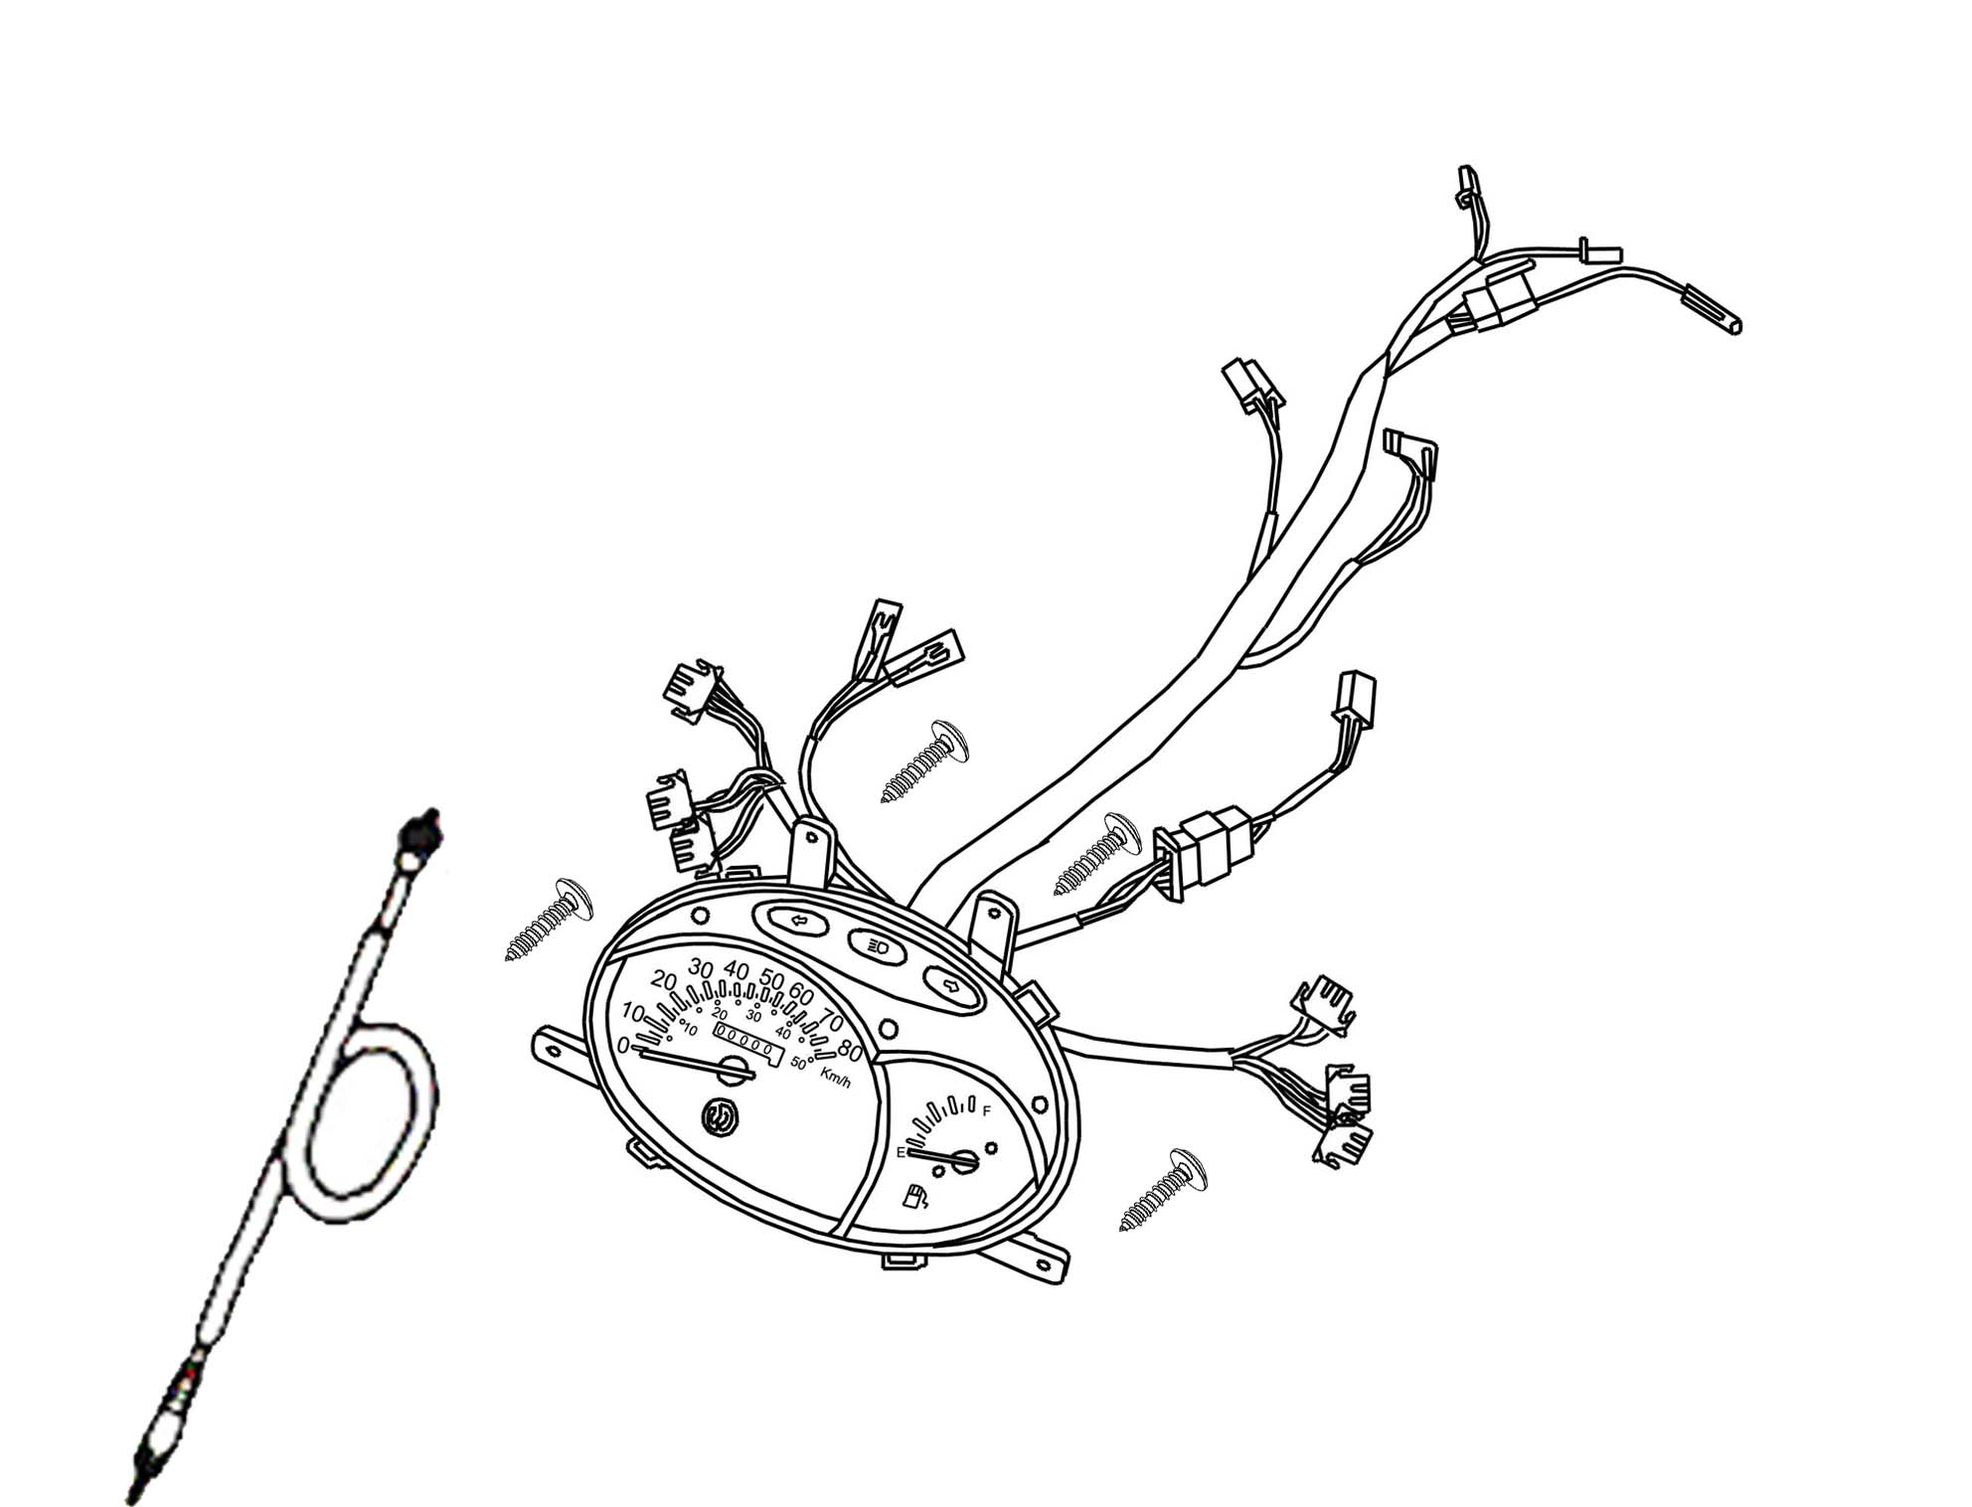
3
3
3
2
1
Ref. No | Part Number | Description |  |  |  |  | Reqd. No
1 | 37200-A2E-0201 | Speedometer ASSY |  | 速度表总成 |  |  | 1
2 | 44830-ABA-0003 | Speedometer cable COMP |  | 速度表导线总才成 |  |  | 1
3 | 90109-48168 | Tapping screw 4.8X16 |  | 攻丝螺钉4.8X16 |  |  | 4
F-03 Cable • Switch • Handle Lever
15
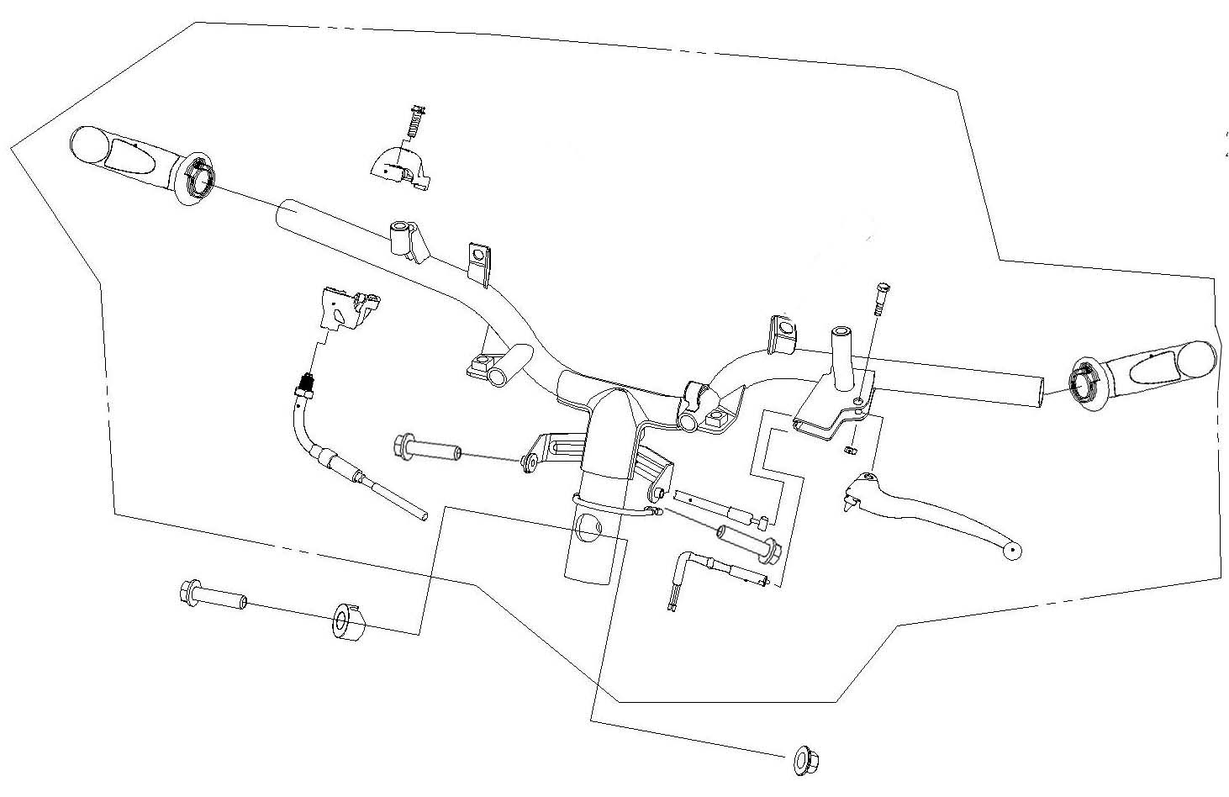
11
16
15
14
13
12
5
10
9
8
7
6
4
3
2
1

Ref. No | Part Number |  | Description |  |  | Reqd. No
1 | 17910-ABA-0003 |  | Throt cable COMP |  | 节流导线夹 | 1
2 | 35340-M92-0001 |  | FR. Stop SW. ASSY |  | 前刹车开关 | 1
3 | 43450-A2E-0000 |  | RR. brake cable COMP |  | 后刹车导线组 | 1
4 | 53100-ALA-0004 |  | STRG. handle |  | 把手 | 1
5 | 53178-ATA-0000 |  | L. STRG. handle lever |  | 左把手拉杆 | 1
6 | 53125-CT1C-A000 |  | HNDL. set collar |  | 把手套环 | 1
7 | 53140-S1F-H001 |  | RH. HNDL. grip (黑色) |  | 右把手节流管 | 1
8 | 53166-S1F-H001 |  | LH. HNDL. grip (黑色) |  | 左把手节流管 | 1
9 | 53167-H09-9001 |  | THROT. UND. housing |  | 节流管下固定座 | 1
10 | 53168-H09-0001 |  | Up thort housing |  | 节流管上固定座 | 1
11 | 94050-10080 |  | Flange nut 10MM |  | 缘面螺母10MM | 1
12 | 90106-AAA-0000 |  | Flange bolt 10X50 |  | 缘面螺栓10*50 | 1
13 | 90115-M9Q-0000 |  | Screw handle lever pivot |  | 把手拉杆螺栓 | 1
14 | 93500-05025-08 |  | Screw bolt |  | 盆状螺栓 | 1
15 | 90118-HAA-0000 |  | Washer bolt 5X14 |  | 带垫螺栓5*14 | 2
16 | 94001-05070-0S |  | Hex nut 5MM |  | 螺母5MM | 1
 |  |  | 12

F-04 Front Brake Master Cylinder
4
10
9
8
8
7
7
7
7
6
6
5
3
2
1
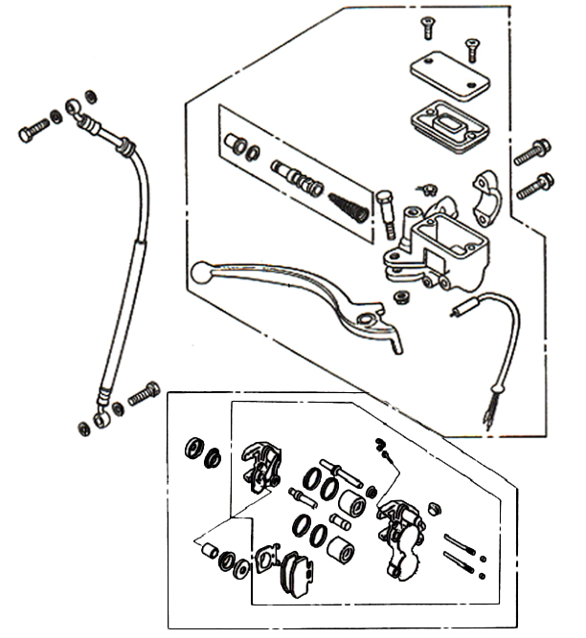
Ref. No | Part Number |  |  | Description |  |  |  | Reqd. No
1 | 35342-M9Q-0000 |  |  | FR. stop SW. ASSY | 前刹车开关总成 |  |  | 1
2 | 45100-T6R-9004 |  |  | Caliper ASSY | 夹具组 |  |  | 1
3 | 45126-ALA-0000 |  |  | FR. brake hose ASSY | 前刹车导管总成 |  |  | 1
4 | 4550A-ALA-0004-M3 |  |  | FR. master cylinder ASSY | 前碟刹泵总成 |  |  | 1
5 | 45500-AAA-0002 |  |  | FR. M/C ASSY | 前碟刹泵总成 |  |  | 1
6 | 90145-M9Q-0000 |  |  | Oil bolt M10x22 | 螺栓M10X22 |  |  | 2
7 | 90545-M9Q-0000 |  |  | Oil bolt washer | 螺栓垫圈 |  |  | 4
8 | 95801-06022-07 |  |  | Flange bolt 6*22 | 六角缘面螺栓6*22 |  |  | 2
9 | 45105-AJF-0000 |  |  | Pad A COMP | 来令片A |  |  | 1
10 | 45106-AJF-0000 |  |  | Pad B COMP | 来令片B |  |  | 1
F-05 Handle Pipe • Handle Cover
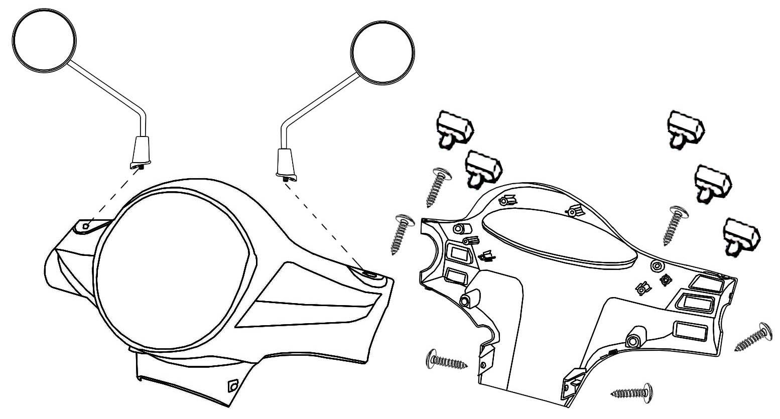
9
8
11
11
10
10
10
10
7
6
5
4
3
2
1
Ref. No | Part Number |  | Description |  |  |  |  |  | Reqd. No
1 | 35150-M9F-A000 |  | LIGHTING.SW.UNIT |  |  |  | 大灯开关 |  | 1
2 | 35160-Z7A-0000 |  | Start SW. UNIT |  |  |  | 起动开关 |  | 1
3 | 35170-A45-0003 |  | Dimmer&seat open SW. UNIT |  |  |  | 远近灯开关 |  | 1
4 | 35180-Z7A-0000 |  | Horn SW. UNIT |  |  |  | 喇叭开关 |  | 1
5 | 35200-M9Q-0001 |  | Winker SW. UNIT |  |  |  | 转向灯开关 |  | 1
6 | 53205-ALA-0001 |  | FR. handle cover |  |  |  | 前把手盖 |  | 1
7 | 53206-ALA-0002 |  | RR. handle cover (黑色) |  |  |  | 后把手盖 |  | 1
8 | 88110-ALA-0001 |  | R back mirror ASSY |  |  |  | 右后视镜 |  | 1
9 | 88120-ALA-0001 |  | L back mirror ASSY |  |  |  | 左后视镜 |  | 1
10 | 90109-42128 |  | Tapping screw 4.2X12 |  |  |  | 盘头自攻螺丝4.2*12 |  | 4
11 | 90118-HAA-0000 |  | Washer bolt 5*14 |  |  |  | 带垫螺栓5*14 |  | 2
F-06 Front Cover • Front Inner Box
2
12
15
14
14
14
14
14
14
14
14
13
11
13
13
13
15
15
15
5
10
9
8
7
7
6
5
4
3
2
1
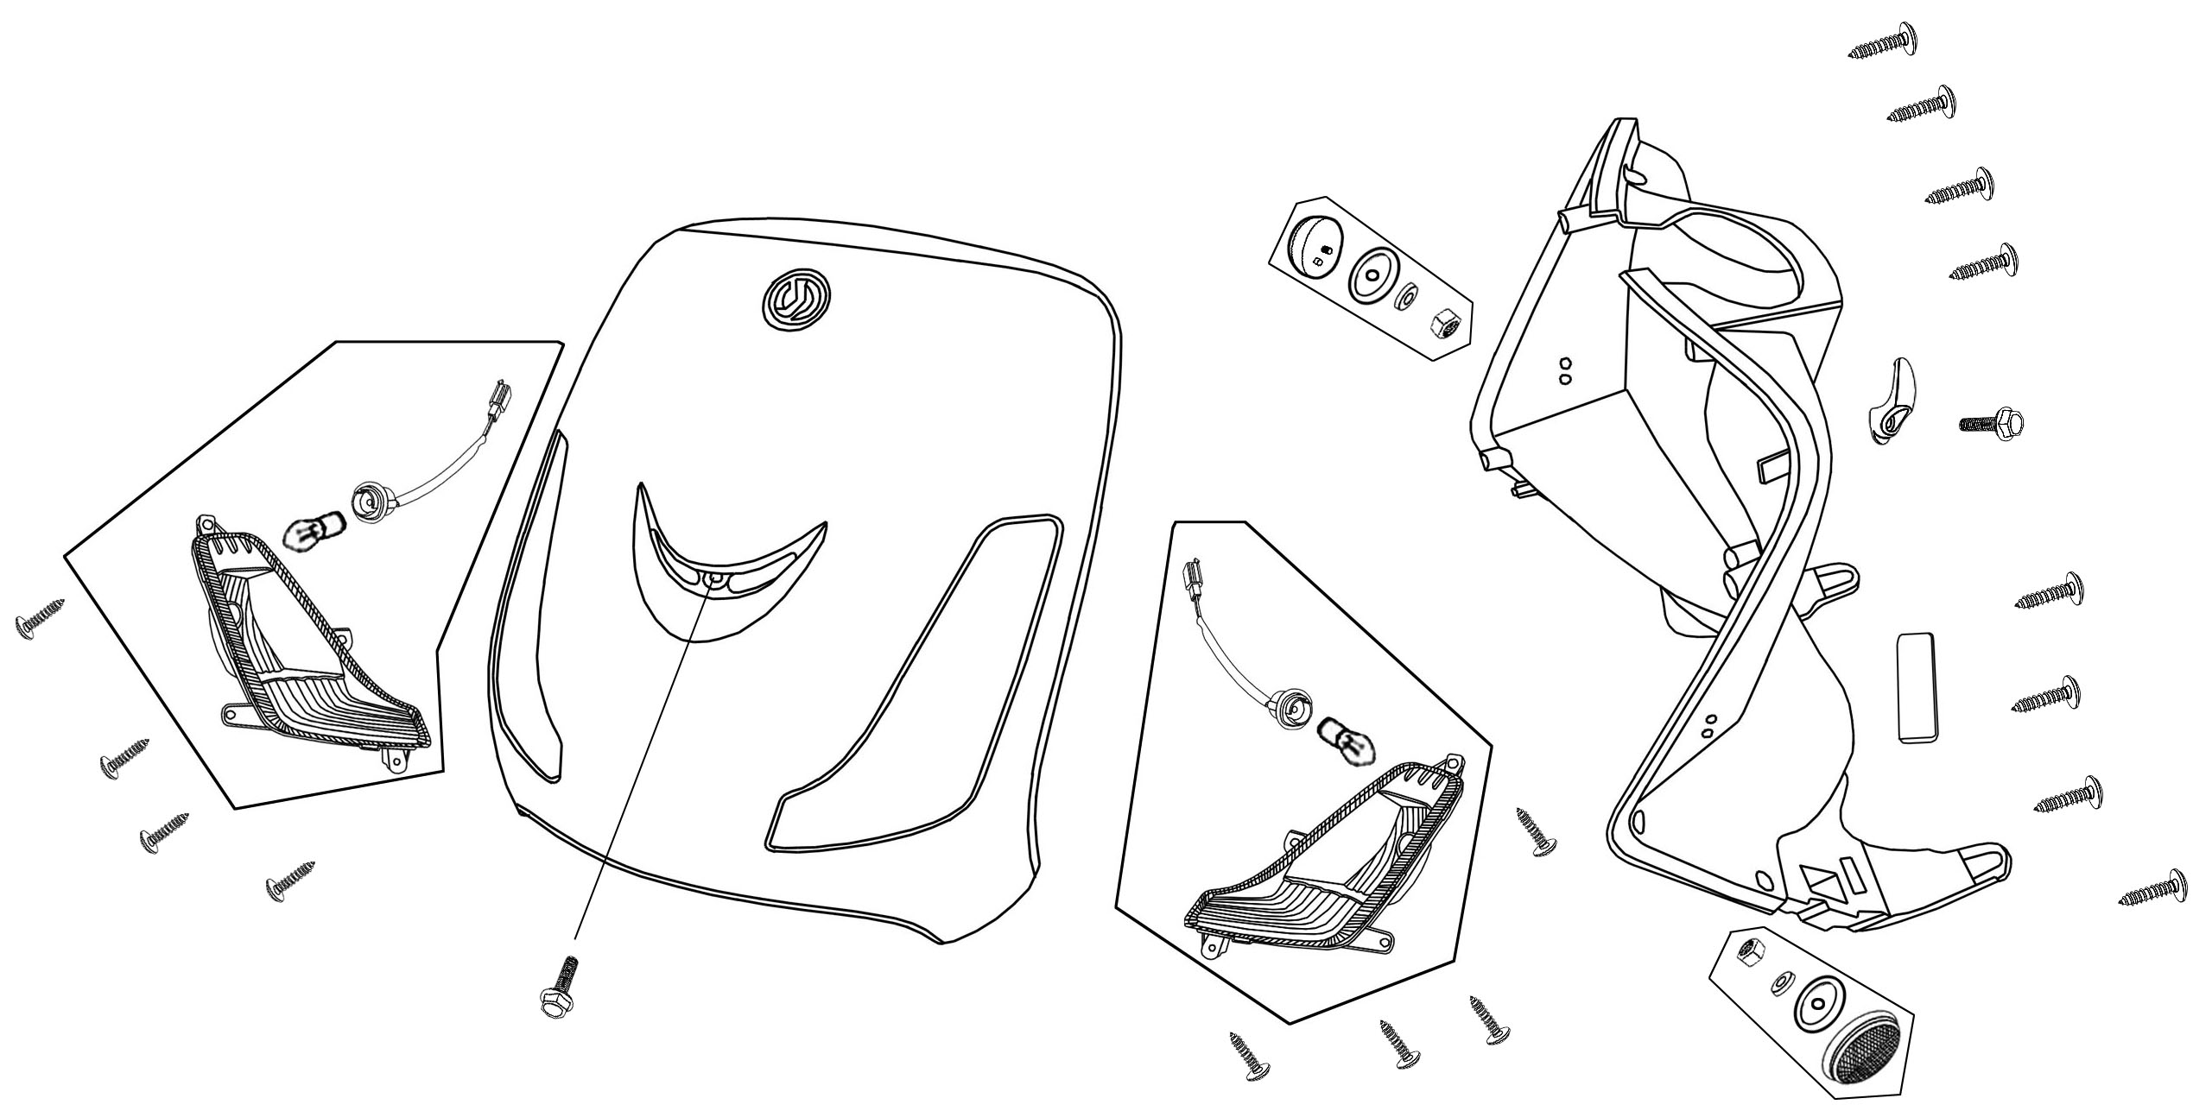
Ref. No | Part Number | Description |  |  |  |  |  |  | Reqd. No
1 | 33400-ALA-0000 | FR. R. winker ASSY |  |  |  | 前右方向灯总成 |  |  | 1
1-1 | 33401-ALA-0000 | FR. R. WINKER BASE |  |  |  | 前右转向灯灯座 |  |  | 1
2 | 87554-AZA-0000 | SYM logo (40 AL) |  |  |  | LOGO |  |  | 1
3 | 33402-ALA-0000 | FR. R. winker lens |  |  |  | 前右转向灯灯壳 |  |  | 1
4 | 33450-ALA-0000 | FR. L. winker ASSY |  |  |  | 前左方向灯总成 |  |  | 1
4-1 | 33451-ALA-0000 | FR. L. winker base |  |  |  | 前左转向灯灯座 |  |  | 1
5 | 81132-M7Q-0001 | Luggage hook |  |  |  | 安全帽挂钩(黑色) |  |  | 1
6 | 33452-ALA-0000 | FR. L. winker lens |  |  |  | 前左转向灯灯壳 |  |  | 1
7 | 34905-A8D-0000 | Winker bulb (12V 10W) |  |  |  | 转向灯灯泡 |  |  | 2
8 | 64301-ALA-0000 | FR. cover |  |  |  | 前面板 |  |  | 1
9 | 64318-ALA-0000-BK | Frame number lid |  |  |  | 车架号码盖(黑色) |  |  | 1
10 | 81131-ALA-0001 | Inner cover |  |  |  | 内护板(咖啡色) |  |  | 1
11 | 90118-HAA-0000 | Washer bolt 5X14 |  |  |  | 带垫螺栓5*14 |  |  | 1
12 | 90115-G02-0000 | Bolt 6X16 |  |  |  | 螺栓6*16 |  |  | 1
13 | 90109-48128 | Tapping screw 4.8X12 |  |  |  | 盘头自攻螺丝4.8*12 |  |  | 8
14 | 90109-48168 | Tapping screw 4.8X16 |  |  |  | 盘头自攻螺丝4.8*16 |  |  | 8

F-07 Floor Panel • Center Cover
8
8
5
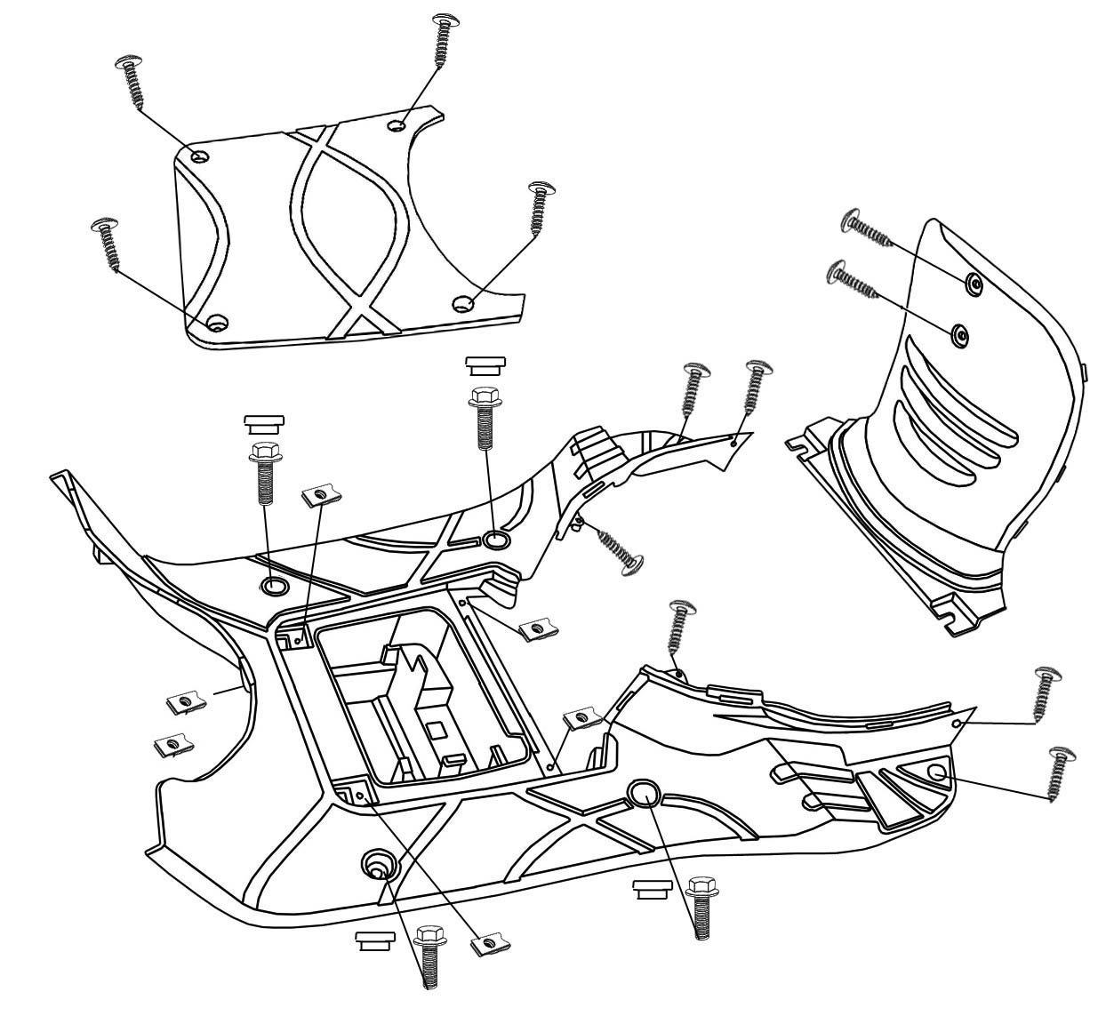
8
8
8
7
7
7
7
9
9
9
9
6
6
5
5
5
5
5
4
3
2
2
2
2
1

Ref. No | Part Number |  | Description |  |  |  |  | Reqd. No
1 | 50326-AAA-0000 |  | Battery cover | 电瓶盖(黑色) |  |  |  | 1
2 | 50612-APA-0000 |  | Cap a floor step | 脚踏板橡皮盖(黑色) |  |  |  | 4
3 | 64310-AKA-0002 |  | Floor panel | 脚踏板(黑色) |  |  |  | 1
4 | 80151-X1A-0000 |  | Center cover | 中央盖(黑色) |  |  |  | 1
5 | 90109-42168 |  | Tapping screw 4.2X16 | 盘头自攻螺丝4.2*16 |  |  |  | 6
6 | 90109-48168 |  | Tapping screw 4.8X16 | 盘头自攻螺丝4.8*16 |  |  |  | 2
7 | 90111-AAA-0000 |  | Flange bolt 6MM | 缘面螺栓6MM |  |  |  | 4
8 | 90308-X04-0000 |  | Spring nut | 夹片螺帽 |  |  |  | 6
9 | 90109-42128 |  | Tapping screw 4.2x12 | 盘头自攻螺丝4.2*12 |  |  |  | 4
F-08 Body Cover
12
6
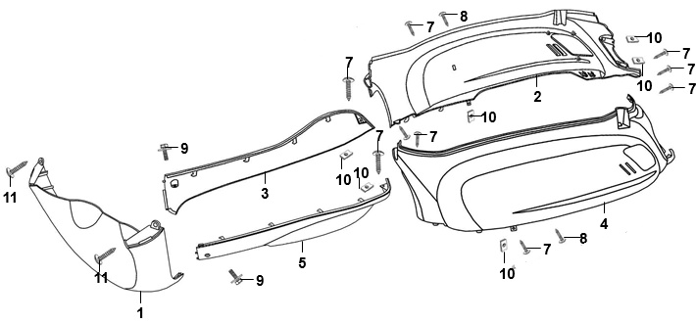

Ref. No | Part Number |  | Description |  |  |  |  |  | Reqd. No
1 | 64300-ALA-0000 |  | FR. spoiler |  | 前护板 |  |  |  | 1
2 | 83500-X1A-0002 |  | RH. body cover |  | 右车体盖 |  |  |  | 1
3 | 83520-ALA-A000 |  | R. side cover |  | 右边条 |  |  |  | 1
4 | 83600-X1A-0002 |  | LH. body cover |  | 左车体盖 |  |  |  | 1
5 | 83620-ALA-A000 |  | L. side cover |  | 左边条 |  |  |  | 1
6-1 | 87127-ALA-0100 |  | R body stripe |  | 右车体盖贴饰 |  |  |  | 1
6-2 | 87128-ALA-0100 |  | L body stripe |  | 左车体盖贴饰 |  |  |  | 1
7 | 90109-42128 |  | Tapping screw 4.2X12 |  | 盘头自攻螺丝4.2*12 |  |  |  | 9
8 | 90109-48128 |  | Tapping screw 4.8X12 |  | 盘头自攻螺丝4.8*12 |  |  |  | 2
9 | 90118-HAA-0000 |  | Washer bolt 5X14 |  | 带垫螺栓5*14 |  |  |  | 2
10 | 90302-M92-0000 |  | Spring nut M4 |  | 夹片螺帽 4MM |  |  |  | 6
11 | 90109-48168 |  | Tapping screw 4.8x16 |  | 盘头自攻螺丝4.8*16 |  |  |  | 2
12 | 87130-X2A-0000 |  | Body cover stripe |  | 车体盖贴饰 |  |  |  | 2
F-09 Steering Stem • Front Cushion
16
16
18
18
18
17
17
17
17
17
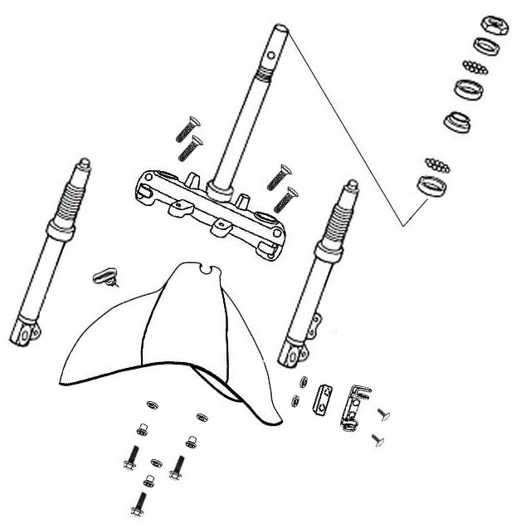
15
15
15
14
13
12
12
12
12
11
10
9
8
7
6
5
3
4
2
1

Ref. No | Part Number |  | Description |  |  |  |  | Reqd. No
1 | 45451-N02-0003 |  | Cable guide |  |  |  | 导线套圈 |  | 1
2 | 45156-XJE-0001 |  | FR. brake hose clamp |  |  |  | 前刹车油管夹 |  | 1
3 | 50301-M9Q-0002-CN2 |  | STRG.up ball race |  |  |  | 上滚珠坐垫 |  | 1
4 | 50302-M9Q-0000-CN2 |  | Race STRG.bot ball |  |  |  | 下钢珠座碗 |  | 1
5 | 50306-M9Q-0000-CN2 |  | STRG. stem lock nut |  |  |  | 方向杆固定螺帽 |  | 1
6 | 51400-AYA-0003 |  | R.FR. cushion |  |  |  | 右前避震 |  | 1
7 | 51500-AYA-0003 |  | L.FR. cushion |  |  |  | 左前避震 |  | 1
8 | 53200-ALA-0002 |  | Steeting stem |  |  |  | 转向主干 |  | 1
9 | 53211-M9Q-0000-CN2 |  | STRG. top cone |  |  |  | 上锥体座 |  | 1
10 | 53212-M9Q-0000-CN2 |  | Cone STRG. bottom |  |  |  | 下锥体座 |  | 1
11 | 61100-ALA-0001 |  | FR. fender |  |  |  | 前轮挡泥板 |  | 1
12 | 95801-08040-00 |  | Flange bolt 8X40 |  |  |  | 缘面螺栓8*40 |  | 4
13 | 50303-AAA-0000 |  | Up steel balls and retainer ASSY ( 3.969*18) |  |  |  | 上钢珠圈 |  | 1
14 | 50304-AAA-0000 |  | Lower steel balls and retainer ASSY ( 6.35*14) |  |  |  | 下钢珠圈 |  | 1
15 | 95801-06020-08 |  | Flange bolt 6*20 |  |  |  | 缘面螺栓6*20 |  | 3
16 | 90110-H6T-0001 |  | Special screw 6*14 |  |  |  | 盘头自攻螺丝6*14 |  | 3
17 | 77226-M3F-0000 |  | Damping rubber |  |  |  | 橡皮 |  | 5
18 | 90104-X04-0002 |  | FR. fork cover collar |  |  |  | 前挡泥板衬套 |  | 3
F-10 Front Wheel
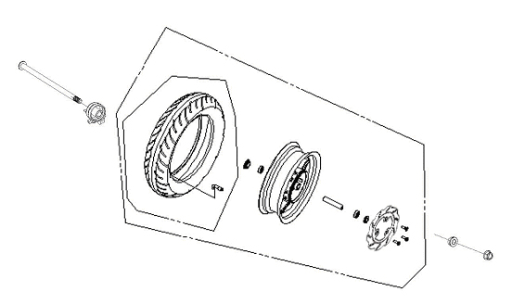
9
13
13
12
11
10
5
8
7
6
4
3
2
1

Ref. No | Part Number | Description |  |  |  |  |  |  |  | Reqd. No
1 | 44710-X1A-0000 | Tire ASS'Y |  |  |  | 轮胎总成 |  |  |  | 1
2 | 42753-ABA-0000 | Rim valve |  |  |  | 气门嘴 |  |  |  | 1
3 | 44301-AAA-0000 | FR. wheel axle |  |  |  | 前轮轴 |  |  |  | 1
4 | 44311-AAA-0000 | Collar fr wheel side |  |  |  | 前轮侧套环 |  |  |  | 1
5 | 45121-AAA-0000 | FR. brake disk |  |  |  | 前碟盘 |  |  |  | 1
6 | 44601-AAA-000 | FR. cast wheel |  |  |  | 前轮圈 |  |  |  | 1
7 | 44620-AAA-0000 | FR. axle dist collar |  |  |  | 轮轴衬套 |  |  |  | 1
8 | 44800-ALA-0002 | SPDMT gear box ASS'Y |  |  |  | 速度表齿轮盒总成 |  |  |  | 1
9 | 91258-M9Q-0000 | SPDMT. gear box seal |  |  |  | 速度表齿轮油封 |  |  |  | 1
10 | 90106-N02-0002 | FR. disk bolt 8*26 |  |  |  | 前碟盘螺栓 |  |  |  | 3
11 | 90306-M9Q-0001 | Self-lock nut 12MM |  |  |  | 轮轴螺母M12 |  |  |  | 1
12 | 90754-M9Q-0000-M1 | Dust seal 20*32*5 |  |  |  | 防尘封 |  |  |  | 1
13 | 90912-M9Q-0000-M1 | Bearing 6201(U) (NTN) |  |  |  | 轴承 |  |  |  | 2

F-11 Rear Wheel
3
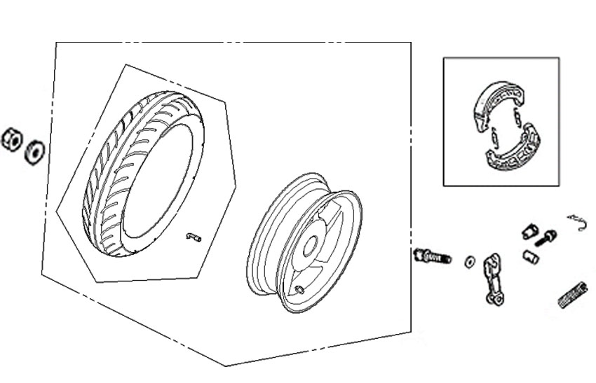
13
12
11
10
8
7
6
5
4
4
2
1
9
Ref. No | Part Number | Description |  | Reqd. No
1 | 42601-ABA-0003 | RR. wheel hub COMP | 后轮圈 | 1
2 | 42710-X1A-0000 | RR. tire ASSY | 后轮胎 | 1
3 | 42753-ABA-0000 | Rim valve | 气门嘴 | 1
5 | 4312A-H1A-0001 | RR. brake shoe ASSY | 刹车皮总成 | 1
6 | 43410-ALG-0000 | RR. brake arm | 后刹车臂 | 1
7 | 43141-ANT-0000 | RR. brake cam | 后刹车凸轮 | 1
8 | 43472-ABA-0000 | RR. BRK. Arm return SRG. | 后刹车臂回位弹簧 | 1
9 | 95015-42000 | Adjust nut B | 调整螺母B | 1
10 | 90305-M9Q-9001 | Self-lock nut 16MM | 自锁螺母16MM | 1
11 | 90501-M9Q-0000 | 16MM washer | 垫片16MM | 1
12 | 91352-M9Q-0000-M1 | O ring 11.3X1.3 | O环11.3X1.3 | 1
13 | 95015-32001 | Brake arm joint B | 后刹车臂接头B | 1

F-12 Seat • Rear Grip
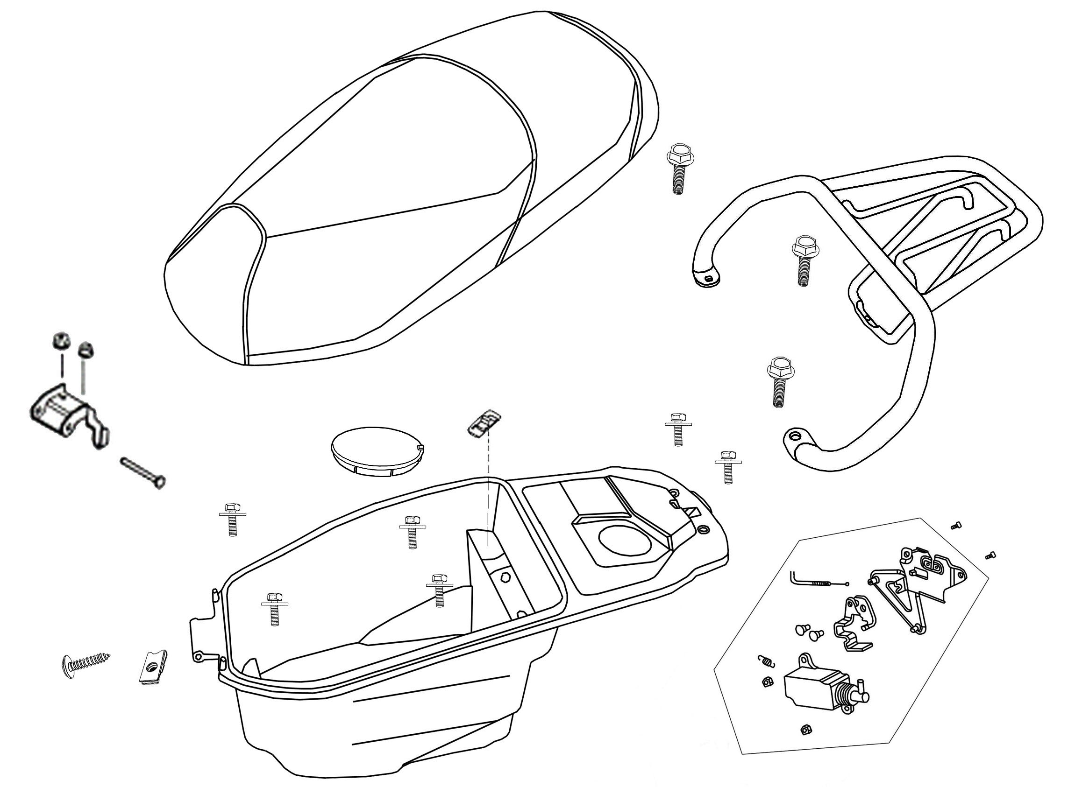
2
10
4
5
6
19
19
8
17
17
16
16
16
7
15
14
11
18
18
17
17
17
17
13
12
9
3
1
Ref. No | Part Number |  | Description |  |  |  |  |  |  |  |  |  |  |  |  | Reqd. No
1 | 36600-A1A-0101 |  | ENG start control SW. |  |  |  |  |  |  |  |  | 引擎熄火开关 |  |  |  | 1
2 | 77200-A2E-1100 |  | Double seat COMP |  |  |  |  |  |  |  |  | 坐垫 |  |  |  | 1
3 | 77201-AAA-0001 |  | Seat hinge |  |  |  |  |  |  |  |  | 座椅铰链 |  |  |  | 1
4 | 77230-ALA-0001 |  | Seat catch COMP |  |  |  |  |  |  |  |  | 坐垫锁 |  |  |  | 1
5 | 77234-M8Q-0000 |  | Seat lock sping |  |  |  |  |  |  |  |  | 坐垫锁弹簧 |  |  |  | 1
6 | 77240-ABA-0001 |  | Seat lock cable |  |  |  |  |  |  |  |  | 坐垫锁导线 |  |  |  | 1
7 | 81200-A2C-0002 |  | RR carrier |  |  |  |  |  |  |  |  | 后货架 |  |  |  | 1
8 | 81250-X1A-0000 |  | Luggage box |  |  |  |  |  |  |  |  | 行李箱 |  |  |  | 1
9 | 81251-ALA-0000 |  | CARB. maint cover |  |  |  |  |  |  |  |  | 化油器调整盖 |  |  |  | 1
10 | 35870-HLA-0001 |  | Dc solenoid ASS'Y |  |  |  |  |  |  |  |  | 电磁阀总成 |  |  |  | 1
11 | 87505-ALA-0000 |  | Tire lable |  |  |  |  |  |  |  |  | 胎压须知 |  |  |  | 1
12 | 87560-E21-0000 |  | Drive caution mark |  |  |  |  |  |  |  |  | 行驶注意 |  |  |  | 1
13 | 90105-T36-0000 |  | Hinge pin |  |  |  |  |  |  |  |  | 铰链销 |  |  |  | 1
14 | 90109-42168 |  | Tapping screw 4.2X16 |  |  |  |  |  |  |  |  | 盘头自攻螺丝4.2*16 |  |  |  | 1
15 | 90308-X04-0000 |  | Spring nut 5MM |  |  |  |  |  |  |  |  | 夹片螺帽5MM |  |  |  | 1
16 | 93401-08020-00 |  | Washer bolt 8X20 |  |  |  |  |  |  |  |  | 带垫螺栓8*20 |  |  |  | 3
17 | 93404-06016-00 |  | Washer bolt 6X16 |  |  |  |  |  |  |  |  | 带垫螺栓6*16 |  |  |  | 6
18 | 94050-06080 |  | Nut flange 6MM |  |  |  |  |  |  |  |  | 缘面螺帽6MM |  |  |  | 2
19 | 95801-06012-08 |  | Flange bolt 6X12 |  |  |  |  |  |  |  |  | 缘面螺栓6*12 |  |  |  | 2
F-13 Fuel Tank
12
12
11
8
7
5
1
15
14
3
10
9
13
13
4
13
13
12
6
11
12
2
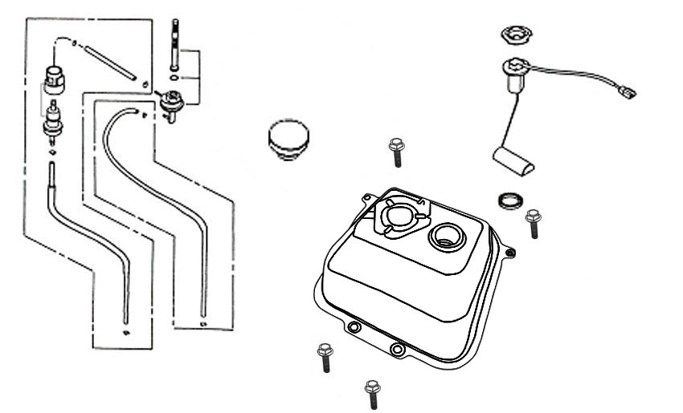
Ref. No | Part Number | Description |  |  |  |  |  |  |  |  |  |  |  | Reqd. No
1 | 16910-M9Q-0001 | Fuel strainer ASSY |  |  |  |  |  | 滤油器总成 |  |  |  |  |  | 1
2 | 16950-M9Q-000A | Fuel cock ASSY |  |  |  |  |  | 油杯总成 |  |  |  |  |  | 1
3 | 17500-AAA-0006 | Fuel tank COMP |  |  |  |  |  | 油箱组 |  |  |  |  |  | 1
4 | 17620-CT1C-9000 | Fuel filler cap COMP |  |  |  |  |  | 油箱盖组 |  |  |  |  |  | 1
5 | 17682-ABA-0002 | Fuel tube（400MM） |  |  |  |  |  | 前油管 |  |  |  |  |  | 1
6 | 17683-AAA-0001 | Fuel tube（170MM） |  |  |  |  |  | 后油管 |  |  |  |  |  | 1
7 | 95003-21025-20 | Vacuum tube |  |  |  |  |  | 真空管 |  |  |  |  |  | 1
8 | 37800-ABA-0100 | Fuel unit |  |  |  |  |  | 汽油油量计 |  |  |  |  |  | 1
9 | 37801-M9Q-0001 | Base packing |  |  |  |  |  | 油量计垫圈 |  |  |  |  |  | 1
10 | 37802-M9Q-0000 | Ret fuel unit |  |  |  |  |  | 油量计压板 |  |  |  |  |  | 1
11 | 95002-02070 | Tube clip B7 |  |  |  |  |  | 负压管卡簧B7 |  |  |  |  |  | 2
12 | 95002-02080 | Tube clip B8 |  |  |  |  |  | 油管卡簧B8 |  |  |  |  |  | 4
13 | 95801-06012-08 | Flange bolt 6X12 |  |  |  |  |  | 缘面螺栓6*12 |  |  |  |  |  | 4
14 | 16905-ABA-0000 | Strainer |  |  |  |  |  | 过滤器 |  |  |  |  |  | 1
15 | 17684-ABA-0000 | Vacuum tube |  |  |  |  |  | 负压管 |  |  |  |  |  | 1
F-14 Battery • Tool Box

4
3
2
1
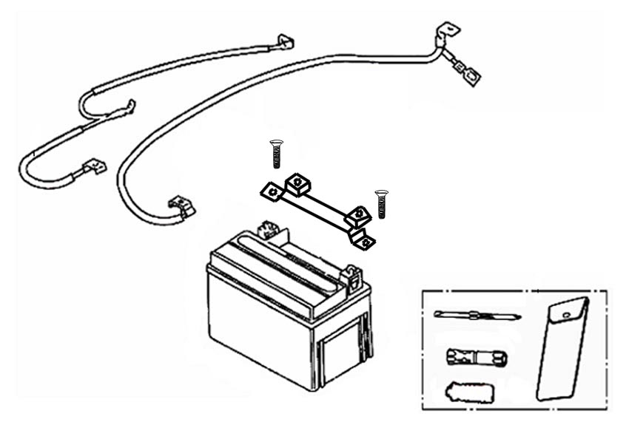

Ref. No | Part Number |  |  | Description |  |  |  |  |  |  |  |  |  | Reqd. No
1 | 31500-AWA-0000 |  |  | Battery ASSY |  |  | 电瓶总成 |  |  |  |  |  |  | 1
2 | 32411-ABA-0100 |  |  | Battery cable |  |  | 电瓶火线 |  |  |  |  |  |  | 1
3 | 32412-ABA-0001 |  |  | Earth cable |  |  | 地线 |  |  |  |  |  |  | 1
4 | 89010-V1F-0000 |  |  | Tool set |  |  | 工具组 |  |  |  |  |  |  | 1
F-15 Air Cleaner
3
3
2
1,4
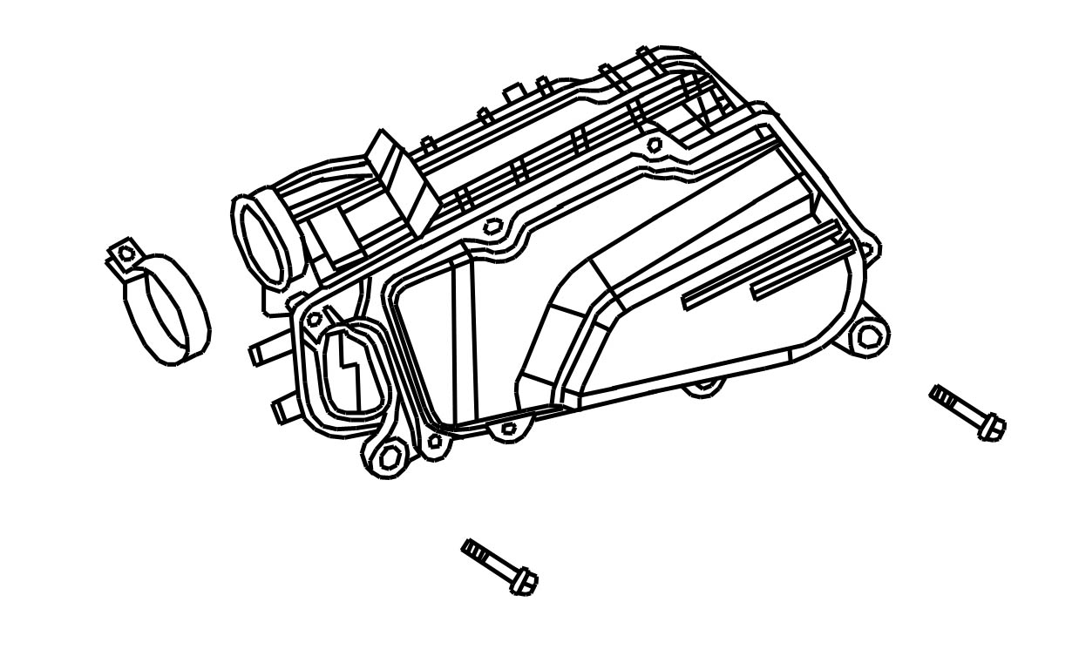

Ref. No | Part Number | Description |  |  |  |  |  |  |  |  |  |  |  | Reqd. No
1 | 17200-ALA-0001 | AIR/C ASSY |  |  |  |  |  |  | 空滤器总成 |  |  |  |  | 1
2 | 90652-M9Q-0000 | Band 48 AIR/C conn tube |  |  |  |  |  |  | 连接管 |  |  |  |  | 1
3 | 95701-06025-07 | Flange bolt 6X25 |  |  |  |  |  |  | 缘面螺栓6*25 |  |  |  |  | 2
4 | 17211-M9Q-0001 | AIR/C ELEMENT COMP |  |  |  |  |  |  | 滤芯组 |  |  |  |  | 1
F-16 Exhaust Muffler
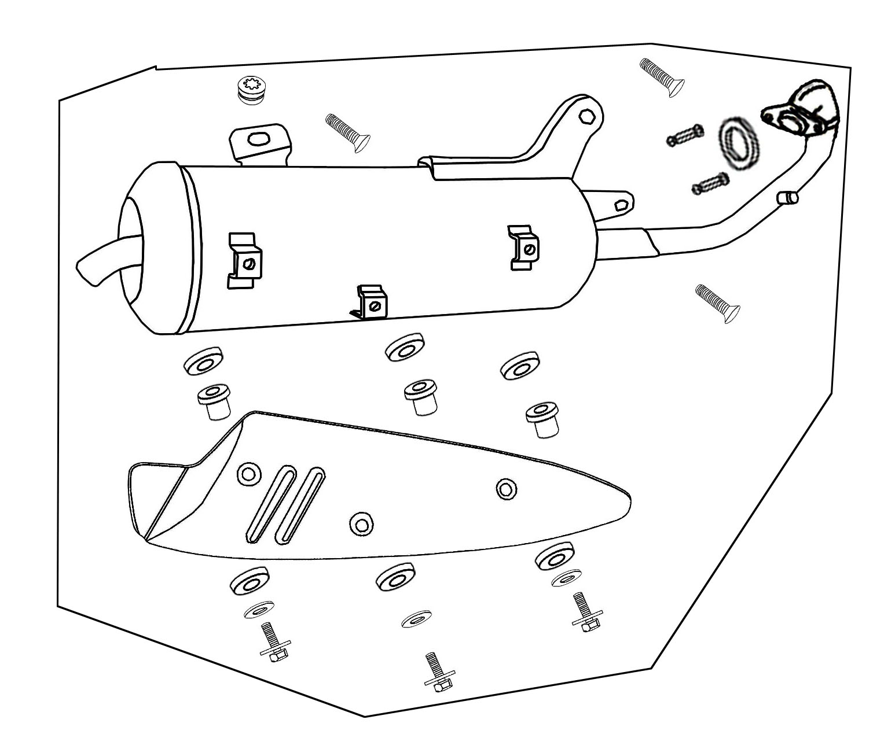
13
12
12
12
11
10
9
9
9
8
8
7
6
5
5
5
4
4
4
3
3
3
2
1
Ref. No | Part Number |  |  |  | Description |  |  |  |  |  |  |  |  | Reqd. No
1 | 18000-A2E-0200 |  |  |  | Exhaust muffler ASSY |  |  |  |  |  |  |  | 排气管总成 | 1
2 | 18291-Z8G-0000 |  |  |  | EXH. pipe gasket |  |  |  |  |  |  |  | 排气管垫片 | 1
3 | 18292-A6A-0001 |  |  |  | Protector packing A |  |  |  |  |  |  |  | 隔热垫片A | 3
4 | 18293-F3E-0000 |  |  |  | Protector packing B |  |  |  |  |  |  |  | 隔热垫片 B | 3
5 | 18295-F3E-0001 |  |  |  | Collar M6 |  |  |  |  |  |  |  | 衬套 | 3
6 | 18318-ALA-0000 |  |  |  | Muffler protector COMP |  |  |  |  |  |  |  | 排气管护热盖 | 1
7 | 18321-ADB-0000 |  |  |  | RR. mudguard stay rubber |  |  |  |  |  |  |  | 后内挡泥板橡皮 | 1
8 | 90301-V1F-0000 |  |  |  | HEX. cap nut 6MM |  |  |  |  |  |  |  | 袋形螺帽6MM | 2
9 | 90555-T3A-A000 |  |  |  | Washer |  |  |  |  |  |  |  | 不锈钢垫片 | 3
10 | 95801-08045-07 |  |  |  | Flange bolt M8X45 |  |  |  |  |  |  |  | 缘面螺栓8*45 | 1
11 | 95801-08055-07 |  |  |  | Flange bolt 8X55 |  |  |  |  |  |  |  | 缘面螺栓8*55 | 1
12 | 96001-06022-49 |  |  |  | SH. flange bolt 6X22 |  |  |  |  |  |  |  | 不锈钢螺栓 | 3
13 | 18300-A2E-0200 |  |  |  | Exhaust muffler |  |  |  |  |  |  |  | 排气管 | 1
F-17 Main Stand • Kick Starter Arm

10
10
9
11
12
7
8
6
5
4
4
3
3
2
1
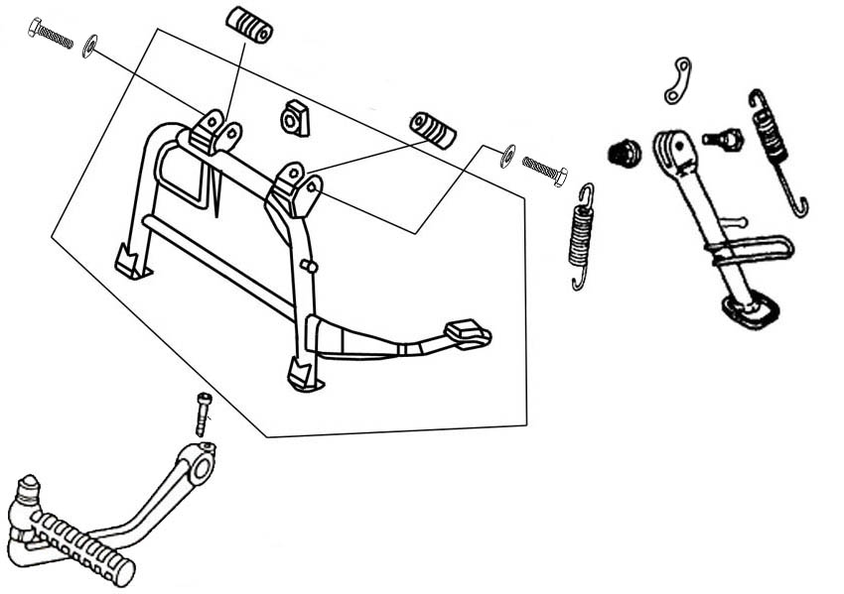
Ref. No | Part Number |  | Description |  |  |  |  |  |  |  |  |  |  |  |  | Reqd. No
1 | 28300-GY6-900A |  | Kick starter arm ASSY |  |  |  |  |  |  |  | 启动杆总成 |  |  |  |  | 1
2 | 50500-ABC-0002 |  | Main stand COMP |  |  |  |  |  |  |  | 主脚架 |  |  |  |  | 1
3 | 50503-A5C-0000 |  | Main stand washer |  |  |  |  |  |  |  | 主脚架垫片 |  |  |  |  | 2
4 | 50504-KAA-0000 |  | Main stand collar |  |  |  |  |  |  |  | 主脚架衬套 |  |  |  |  | 2
5 | 5052A-APA-9000 |  | Main stand SPG.ASSY |  |  |  |  |  |  |  | 主脚架弹簧 |  |  |  |  | 1
6 | 50506-ABA-0000 |  | Stand stop rubber A |  |  |  |  |  |  |  | 制止橡皮 |  |  |  |  | 1
7 | 50533-Z7C-0000 |  | Side stand SPG. ASSY |  |  |  |  |  |  |  | 侧脚架弹簧 |  |  |  |  | 1
8 | 50530-ALA-0000 |  | Side stand COMP |  |  |  |  |  |  |  | 侧脚架总成 |  |  |  |  | 1
9 | 95701-06022-07 |  | Flange bolt 6X22 |  |  |  |  |  |  |  | 缘面螺栓6*22 |  |  |  |  | 1
10 | 95801-08045-00 |  | Flange bolt 8X45 |  |  |  |  |  |  |  | 缘面螺栓8*45 |  |  |  |  | 2
11 | 90108-AAG-0000 |  | Side stand pivot screw |  |  |  |  |  |  |  | 侧脚架螺栓 |  |  |  |  | 1
12 | 94030-08000 |  | HEX. nut 8MM |  |  |  |  |  |  |  | 六角螺帽8MM |  |  |  |  | 1
F-18 Tail Light • RR. Cushion
14
13
13
13
13
13
13
12
11
10
10
9
8
7
6
5
4
3
2
1
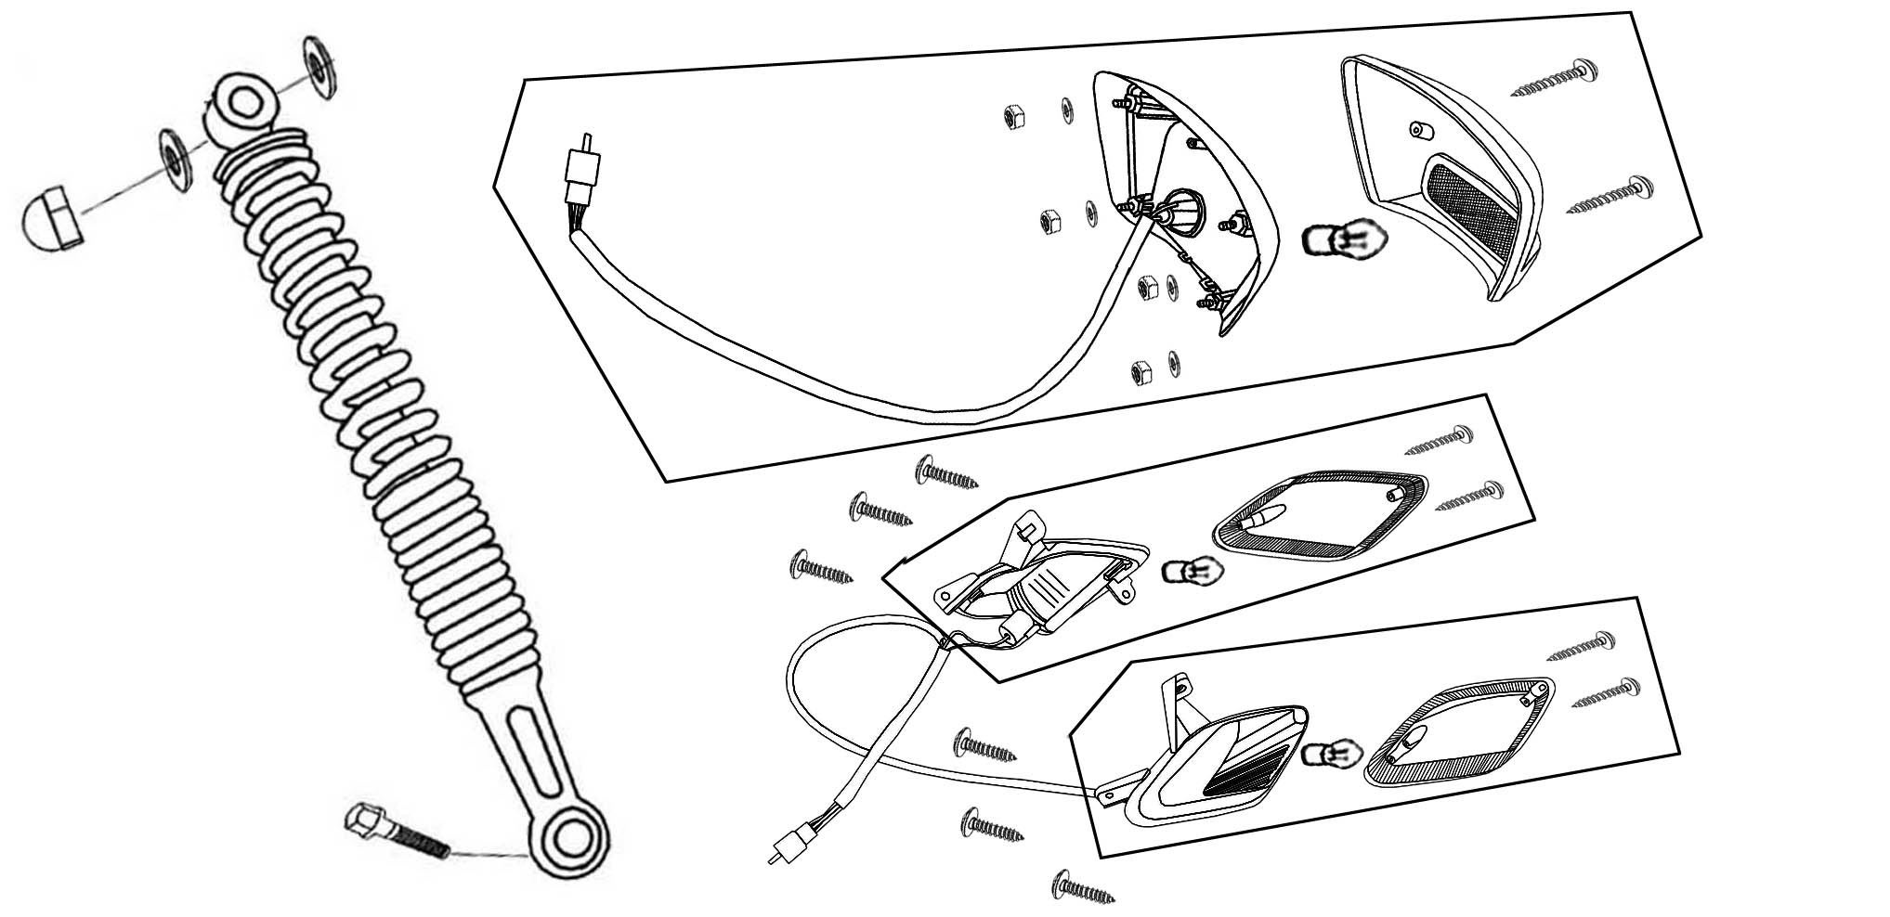
Ref. No | Part Number |  |  |  | Description |  |  |  |  |  |  |  |  | Reqd. No
1 | 33600-ALA-0002 |  |  |  | RR. R. winker ASSY |  |  |  |  | 后右方向灯总成 |  |  |  | 1
2 | 33601-ALA-0000 |  |  |  | RR. R. winker base |  |  |  |  | 后右方向灯支座 |  |  |  | 1
3 | 33602-ALA-0000 |  |  |  | RR. R. winker lens |  |  |  |  | 后右方向灯灯壳 |  |  |  | 1
4 | 33650-ALA-0002 |  |  |  | RR. L. winker ASSY |  |  |  |  | 后左方向灯总成 |  |  |  | 1
5 | 33651-ALA-0000 |  |  |  | RR. L. winker base |  |  |  |  | 后左方向灯支座 |  |  |  | 1
6 | 33652-ALA-0000 |  |  |  | RR. L. winker lens |  |  |  |  | 后左方向灯灯壳 |  |  |  | 1
7 | 33700-ALA-0000 |  |  |  | Tail light COMP |  |  |  |  | 尾灯组 |  |  |  | 1
8 | 33701-ALA-0000 |  |  |  | Tail light lens |  |  |  |  | 尾灯灯壳 |  |  |  | 1
9 | 33702-ALA-0000 |  |  |  | Tail light base |  |  |  |  | 尾灯支座 |  |  |  | 1
10 | 34905-A8D-0000 |  |  |  | Winker bulb (12V,10W) |  |  |  |  | 方向灯灯泡 |  |  |  | 2
11 | 34906-M9Q-0001 |  |  |  | Tail light bulb |  |  |  |  | 尾灯灯泡 |  |  |  | 1
12 | 52400-ABA-0101 |  |  |  | RR. cushion ASSY |  |  |  |  | 后减震 |  |  |  | 1
13 | 90109-48128 |  |  |  | Tapping screw 4.8X12 |  |  |  |  | 自功螺丝 |  |  |  | 6
14 | 95801-08035-00 |  |  |  | Hex bolt 8X35 |  |  |  |  | 六角螺栓8*35 |  |  |  | 1
F-19 Rear Fender • Rear Inner Fender
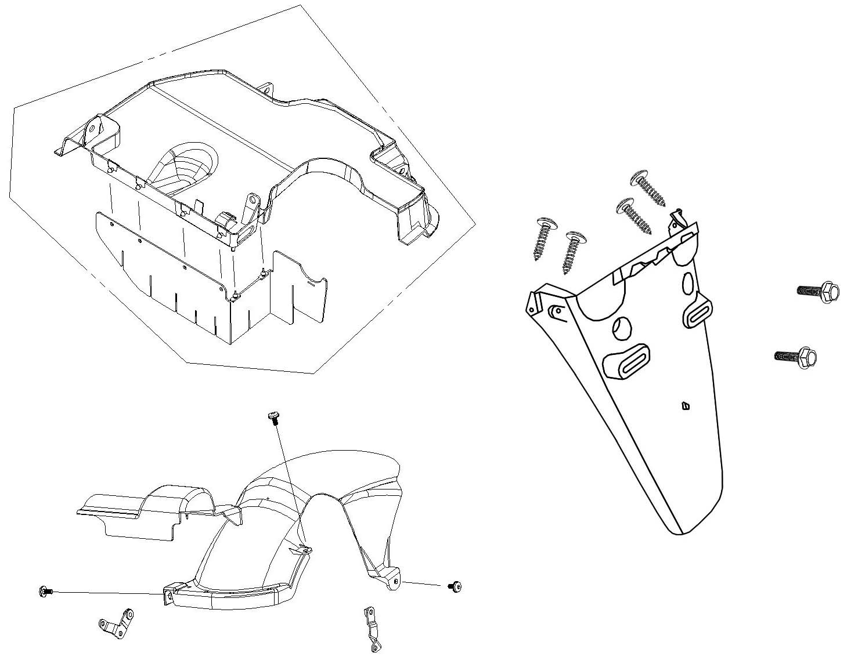
9
9
9
8
8
7
7
7
7
6
4
5
2
3
1
Ref. No | Part Number |  |  |  | Description |  |  |  |  |  |  |  |  |  |  | Reqd. No
1 | 80100-ALA-0001 |  |  |  | RR. fender |  |  |  | 后挡泥板 |  |  |  |  |  |  | 1
2 | 8010B-ALA-0000 |  |  |  | Inner fender ASSY |  |  |  | 内挡泥板总成 |  |  |  |  |  |  | 1
3 | 80104-ABA-0000 |  |  |  | Splash board plate |  |  |  | 防尘片 |  |  |  |  |  |  | 1
4 | 80106-ALA-0004 |  |  |  | RR. inn fender |  |  |  | 后内挡泥板 |  |  |  |  |  |  | 1
5 | 80107-ANA-0003 |  |  |  | RR. mudguard |  |  |  | 后土除 |  |  |  |  |  |  | 1
6 | 80109-ABA-0100 |  |  |  | RR. mudguard stay |  |  |  | 后土除铰链 |  |  |  |  |  |  | 1
7 | 90109-48128 |  |  |  | Tapping screw 4.8X12 |  |  |  | 盘头自攻螺丝4.8*12 |  |  |  |  |  |  | 4
8 | 95801-06012-07 |  |  |  | Flange bolt 6X12 |  |  |  | 缘面螺栓6*12 |  |  |  |  |  |  | 2
9 | 95801-06012-07 |  |  |  | Flange bolt 6X12 |  |  |  | 缘面螺栓6*12 |  |  |  |  |  |  | 3
F-20 Wire Harness
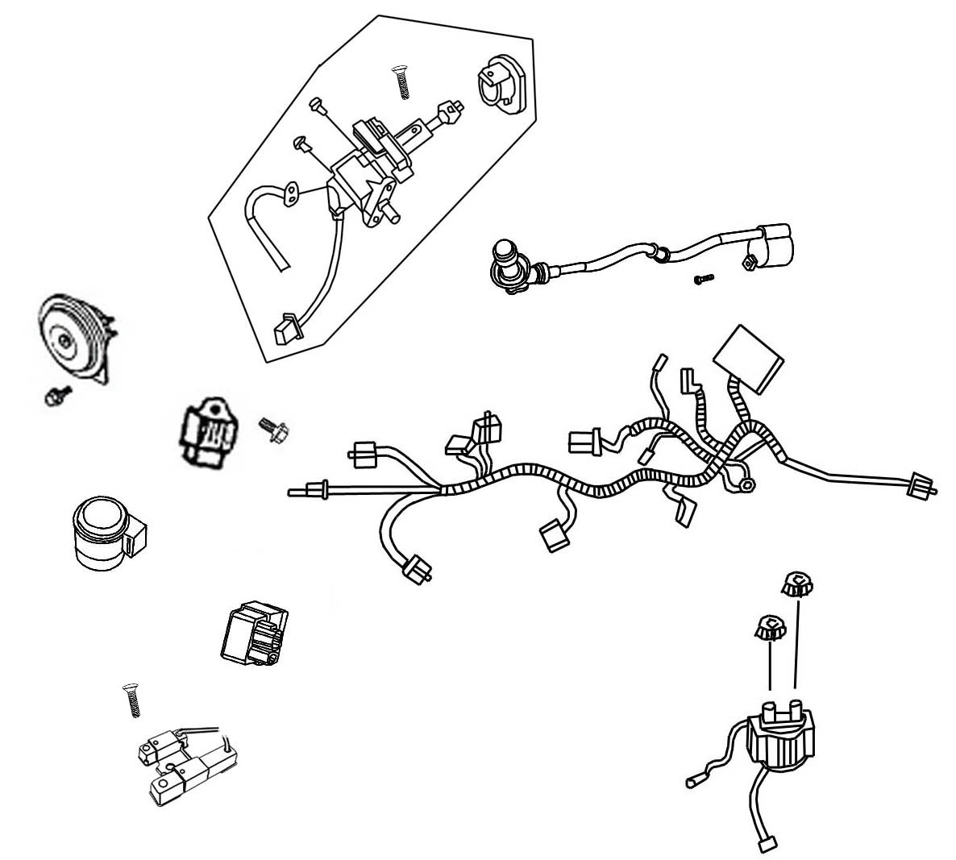
19
18
18
17
17
16
15
14
13
12
11
11
9
8
7
5
6
4
3
10
2
1
Ref. No | Part Number |  |  |  | Description |  |  |  |  |  |  |  |  |  |  |  | Reqd. No
1 | 30410-M92-0004 |  |  |  | CDI. UNIT COMP |  |  |  | CDI组 |  |  |  |  |  |  |  | 1
2 | 3051A-T3D-0101 |  |  |  | IGN. COIL. ASSY |  |  |  | 高压包总成 |  |  |  |  |  |  |  | 1
3 | 31600-ZDA-0002 |  |  |  | REG. REC. COMP |  |  |  | 整流器 |  |  |  |  |  |  |  | 1
4 | 32100-ALA-0101 |  |  |  | Wire harness |  |  |  | 电路主线 |  |  |  |  |  |  |  | 1
5 | 35010-ALA-0100 |  |  |  | Key set |  |  |  | 套锁 |  |  |  |  |  |  |  | 1
6 | 35100-ALA-0100 |  |  |  | Comb sw and lock ASSY |  |  |  | 锁组 |  |  |  |  |  |  |  | 1
7 | 35114-ALA-0000 |  |  |  | Ring |  |  |  | 主开关盖 |  |  |  |  |  |  |  | 1
8 | 35111-AA3-A000 |  |  |  | Key |  |  |  | 钥匙 |  |  |  |  |  |  |  | 1
9 | 35400-M92-0004 |  |  |  | Resistor COMP |  |  |  | 电阻 |  |  |  |  |  |  |  | 1
10 | 3585A-35A-A000 |  |  |  | MAG. SW. COMP |  |  |  | 启动继电器 |  |  |  |  |  |  |  | 1
11 | 35859-M9Q-0001 |  |  |  | Start MAG. SW. NUT |  |  |  | 起动继电器螺帽 |  |  |  |  |  |  |  | 2
12 | 38110-ABA-0002 |  |  |  | Horn COMP |  |  |  | 喇叭 |  |  |  |  |  |  |  | 1
13 | 38300-T40-0101 |  |  |  | Ap winker relay ASSY |  |  |  | 闪光器 |  |  |  |  |  |  |  | 1
14 | 77240-ABA-0001 |  |  |  | Seat lock lable |  |  |  | 坐垫导线锁 |  |  |  |  |  |  |  | 1
15 | 90112-AAA-0000 |  |  |  | Flange bolt 5X22 |  |  |  | 缘面螺栓5*22 |  |  |  |  |  |  |  | 1
16 | 93891-05080 |  |  |  | Screw washer 5X8 |  |  |  | 垫片螺钉5*8 |  |  |  |  |  |  |  | 1
17 | 95801-06012-08 |  |  |  | Flange bolt 6X12 |  |  |  | 缘面螺栓6*12 |  |  |  |  |  |  |  | 2
18 | 95801-06018-00 |  |  |  | Flange bolt 6X18 |  |  |  | 缘面螺栓6*18 |  |  |  |  |  |  |  | 2
19 | 95801-08012-08 |  |  |  | Flange bolt 8X12 |  |  |  | 缘面螺栓8*12 |  |  |  |  |  |  |  | 1
F-21 Frame Body • Engine Hanger
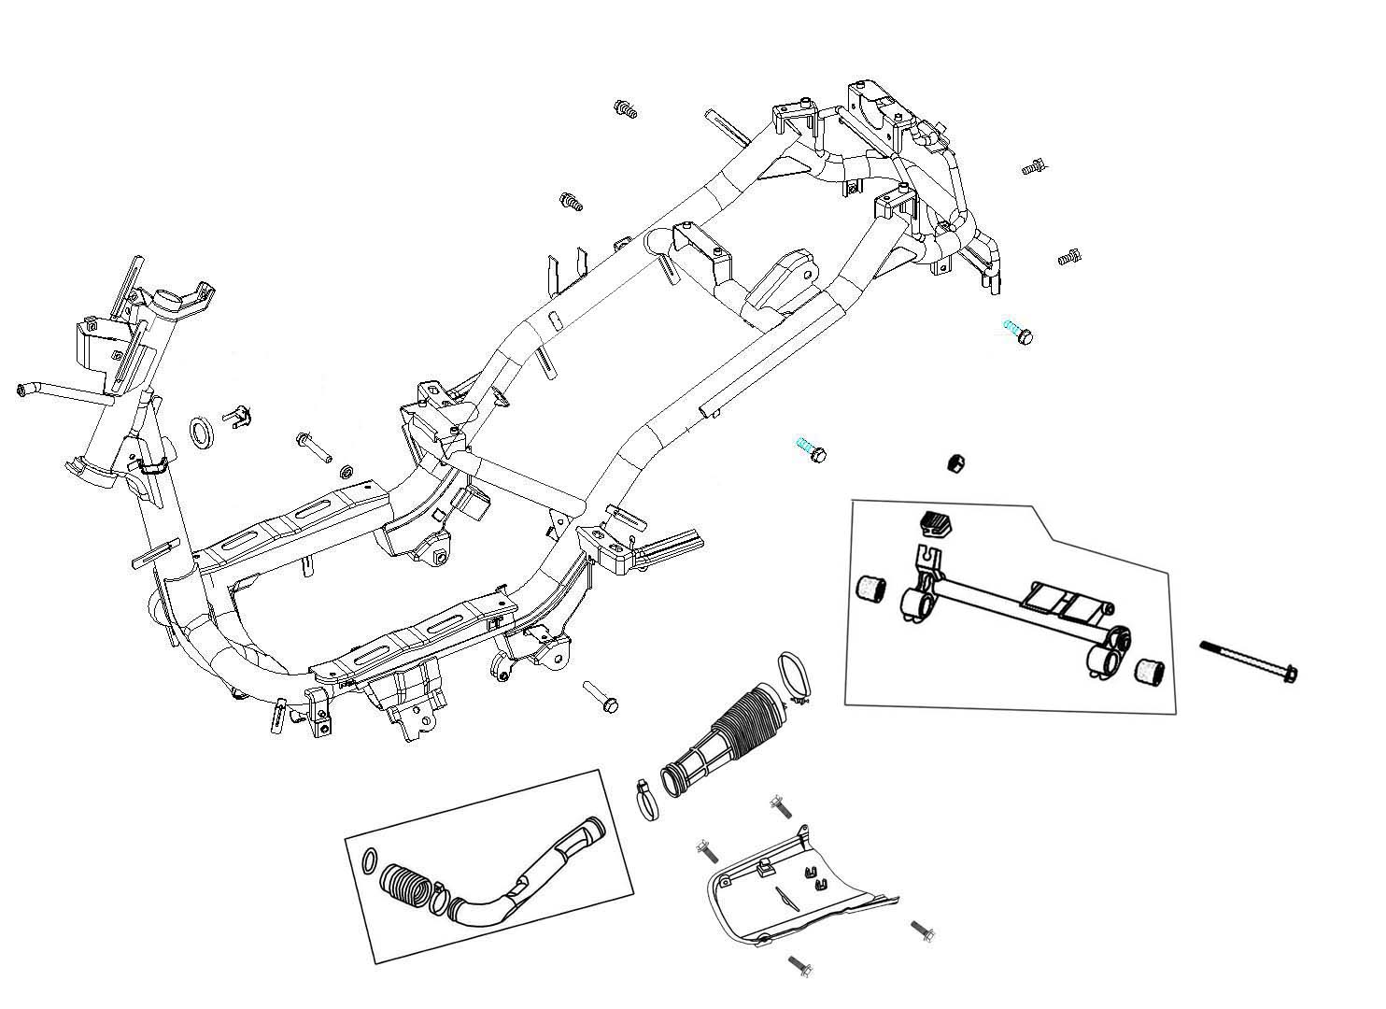
10
3
9
4
6
7
7
5
2
10
10
10
8
1
Ref. No | Part Number | Description |  |  |  |  |  |  |  |  |  |  |  |  | Reqd. No
1 | 11345-ABA-0005 | L. cover duct |  |  |  | 左盖冷却导管 |  |  |  |  |  |  |  |  | 1
2 | 11346-ABA-0000 | L. cover duct band |  |  |  | 左曲轴箱盖冷却导管管夹 |  |  |  |  |  |  |  |  | 1
3 | 50100-A2E-0005 | Frame body COMP |  |  |  | 车架 |  |  |  |  |  |  |  |  | 1
4 | 50350-A2E-0100 | ENG hanger link ASSY |  |  |  | 引擎悬吊总成 |  |  |  |  |  |  |  |  | 1
5 | 50351-A2E-0100 | ENG hanger link |  |  |  | 引擎悬吊 |  |  |  |  |  |  |  |  | 1
6 | 50352-A1A-0000 | Link stopper rubber |  |  |  | 悬吊制止橡皮 |  |  |  |  |  |  |  |  | 1
7 | 50353-M9Q-0000 | Swing lock bush |  |  |  | 悬吊衬套 |  |  |  |  |  |  |  |  | 2
8 | 50613-ALA-0000 | Under cover |  |  |  | 底板 |  |  |  |  |  |  |  |  | 1
9 | 90105-M9Q-8002 | Flange bolt 10*184 |  |  |  | 缘面螺栓10*184 |  |  |  |  |  |  |  |  | 1
10 | 93404-06016-00 | Washer bolt 6X16 |  |  |  | 带垫螺栓6*16 |  |  |  |  |  |  |  |  | 4
F-22 Handle visor
8
8
7
7
7
7
7
7
2
2
2
2
2
4
3
5
6
6
5
1
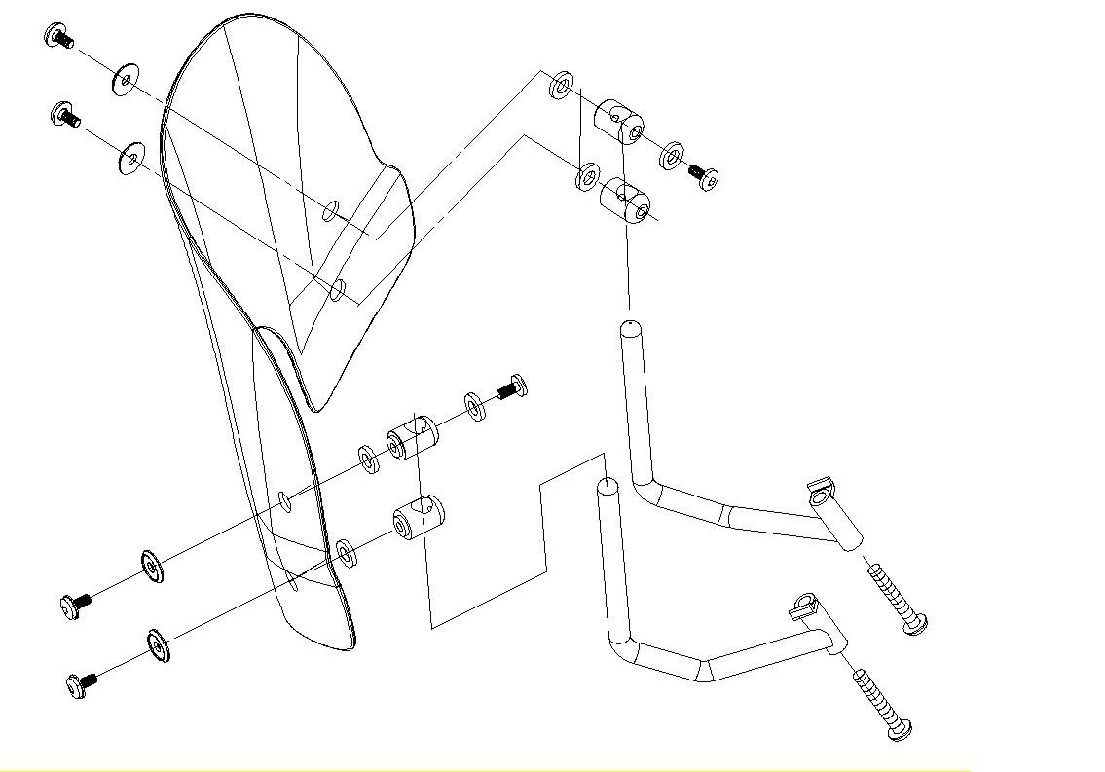

Ref. No | Part Number | Description |  |  |  |  |  |  |  |  |  |  |  |  | Reqd. No
1 | 53270-ALA-0000 | Handle Visor |  |  |  | 把手导流罩 |  |  |  |  |  |  |  |  | 1
2 | 53272-ALA-0000 | Handle Visor Grommet |  |  |  | 套圈 |  |  |  |  |  |  |  |  | 6
3 | 53273-ALA-1000 | R. Handle Visor BAR |  |  |  | 右把手装饰板 |  |  |  |  |  |  |  |  | 1
4 | 53274-ALA-1000 | L. Handle Visor BAR |  |  |  | 左把手装饰板 |  |  |  |  |  |  |  |  | 1
5 | 53275-ALA-1000 | Handle Visor Holder A |  |  |  | 把手导流罩固定器A |  |  |  |  |  |  |  |  | 2
6 | 53276-ALA-0000 | Handle Visor Holder B |  |  |  | 把手导流罩固定器B |  |  |  |  |  |  |  |  | 2
7 | 90110-H6T-0001 | Special Screw 6*14 |  |  |  | 特殊螺丝6*14 |  |  |  |  |  |  |  |  | 6
8 | 95801-08055-07 | Flange Bolt 8*55 |  |  |  | 缘面螺栓8*55 |  |  |  |  |  |  |  |  | 2

